**CLOUD COMPUTING**

**SUBMITTED BY:** ARMEEN ABID **(BSE-011)**

**SUBMITTED TO:** ENGR.MUHAMMAD SHOAIB

**LAB 12**

**Terraform Provisioners, Modules & Nginx Reverse Proxy/Load Balancer**

**TASK 1:**

Lab Setup

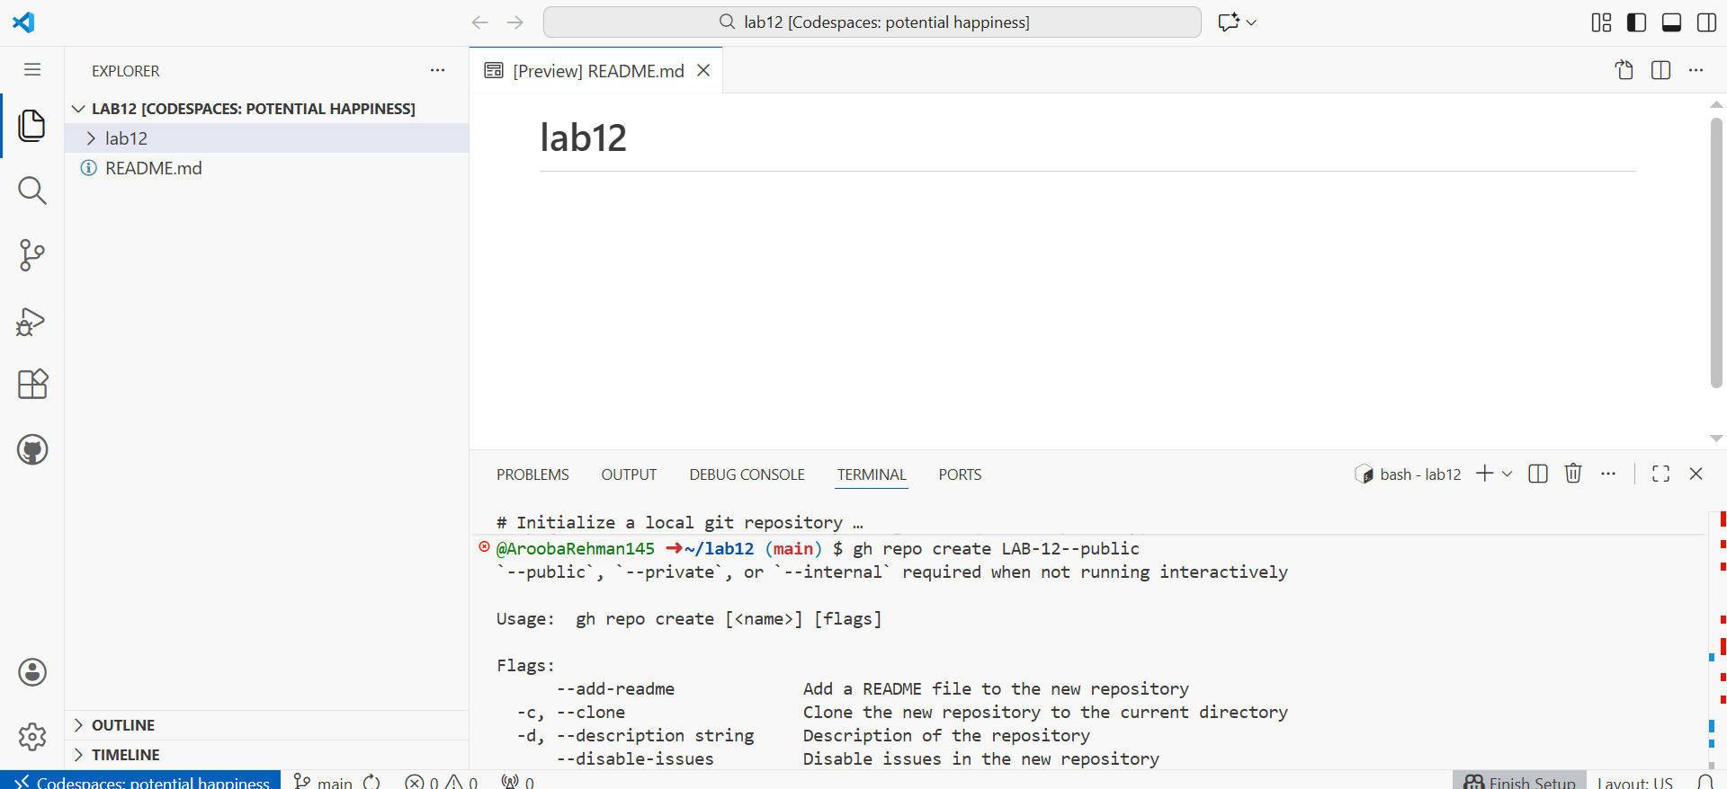

Create the initial project structure:

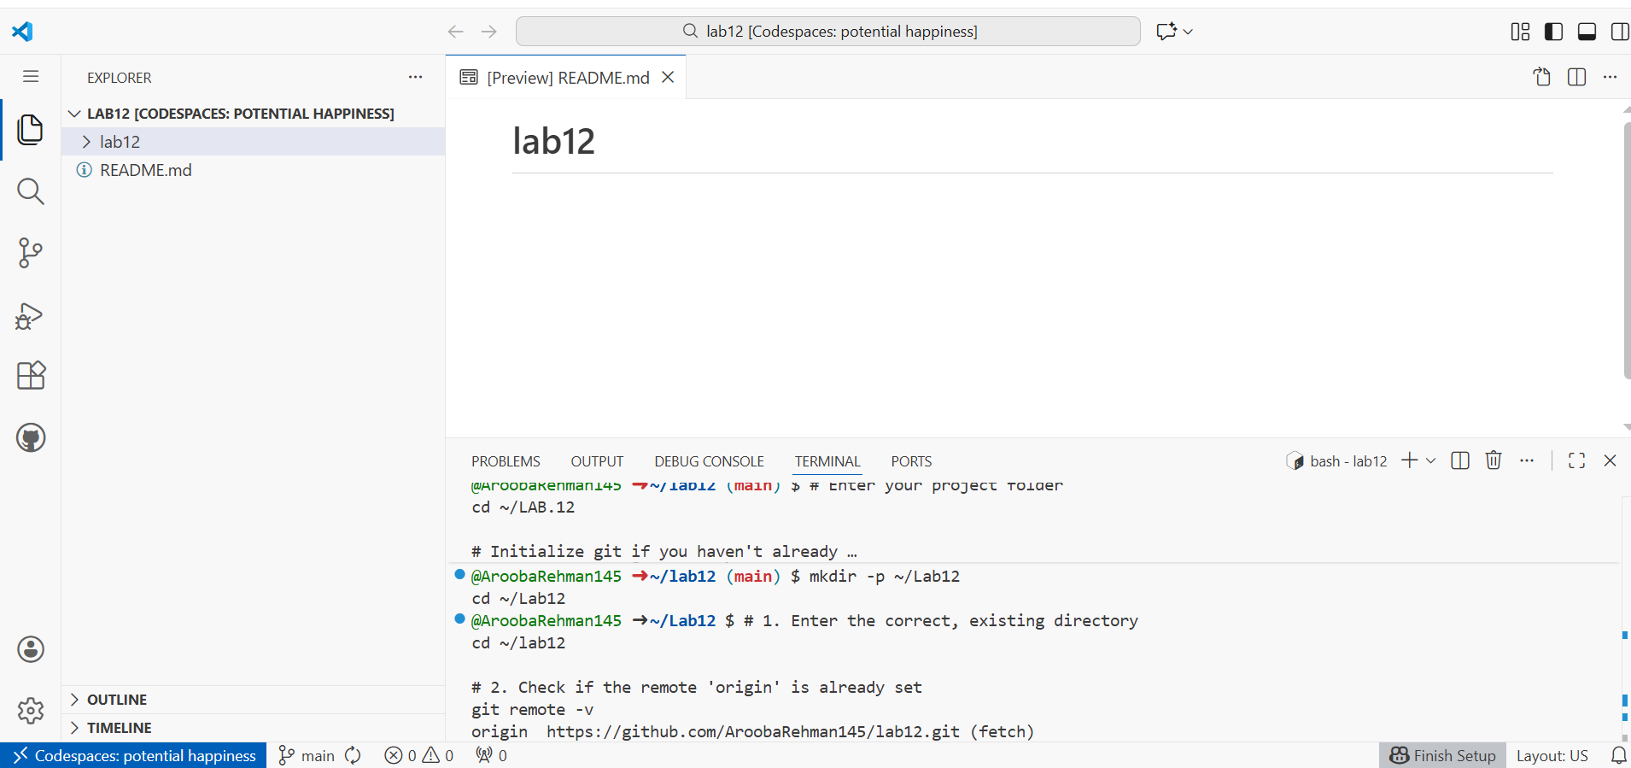

Create all required files:

touch main.tf variables.tf outputs. tf locals.tf terraform.tfvars entry-script.sh

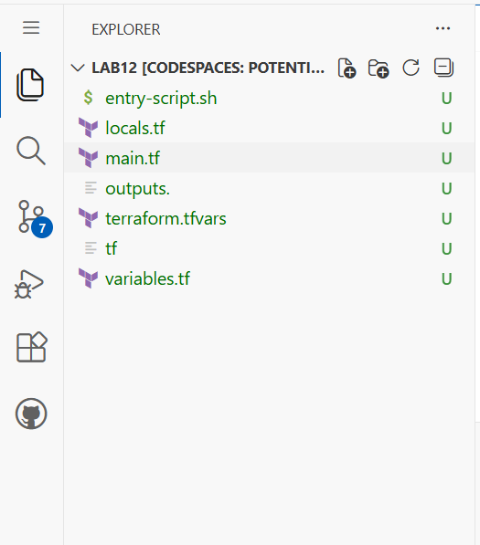

1. Create variables.tf with the following content:
2. variable "vpc_cidr_block" {}
3. variable "subnet_cidr_block" {}
4. variable "availability_zone" {}
5. variable "env_prefix" {}
6. variable "instance_type" {}
7. variable "public_key" {}
8. variable "private_key" {}

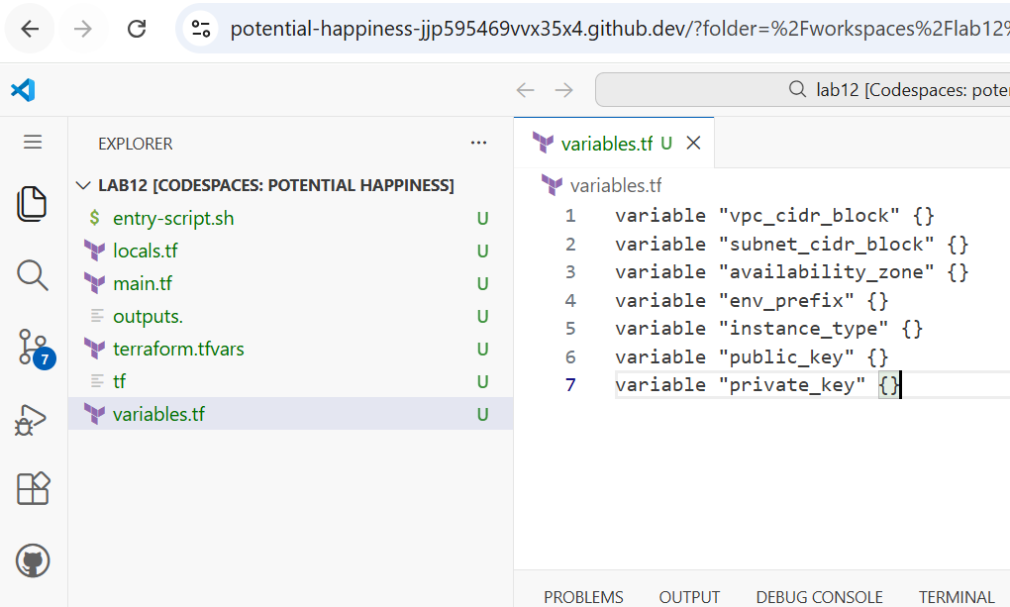

1. Create outputs.tf with the following content:

output "aws_instance_public_ip" {

value = aws_instance.myapp-server.public_ip

}

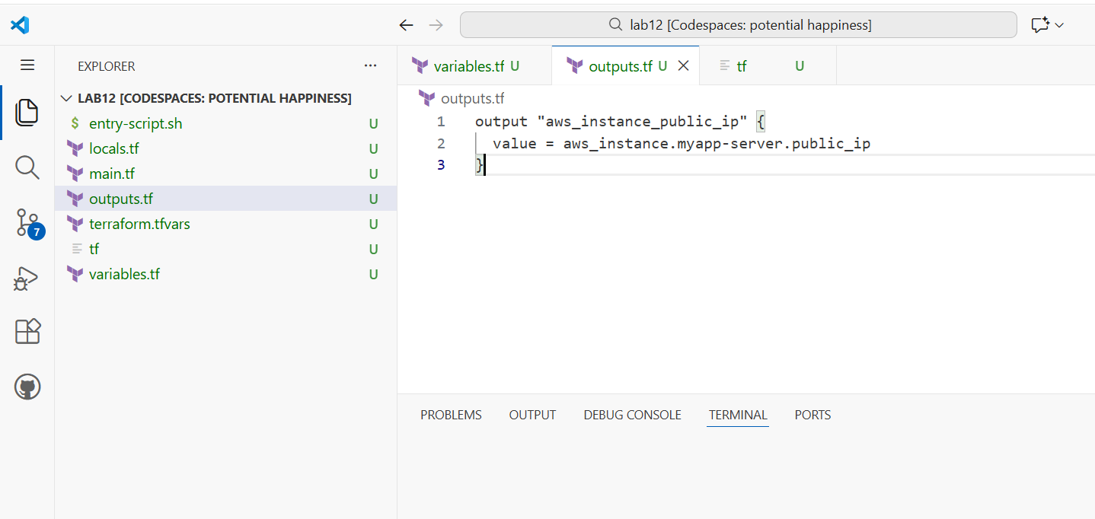

Create locals.tf with the following content

locals {

my_ip = "${chomp(data.http.my_ip.response_body)}/32"

}

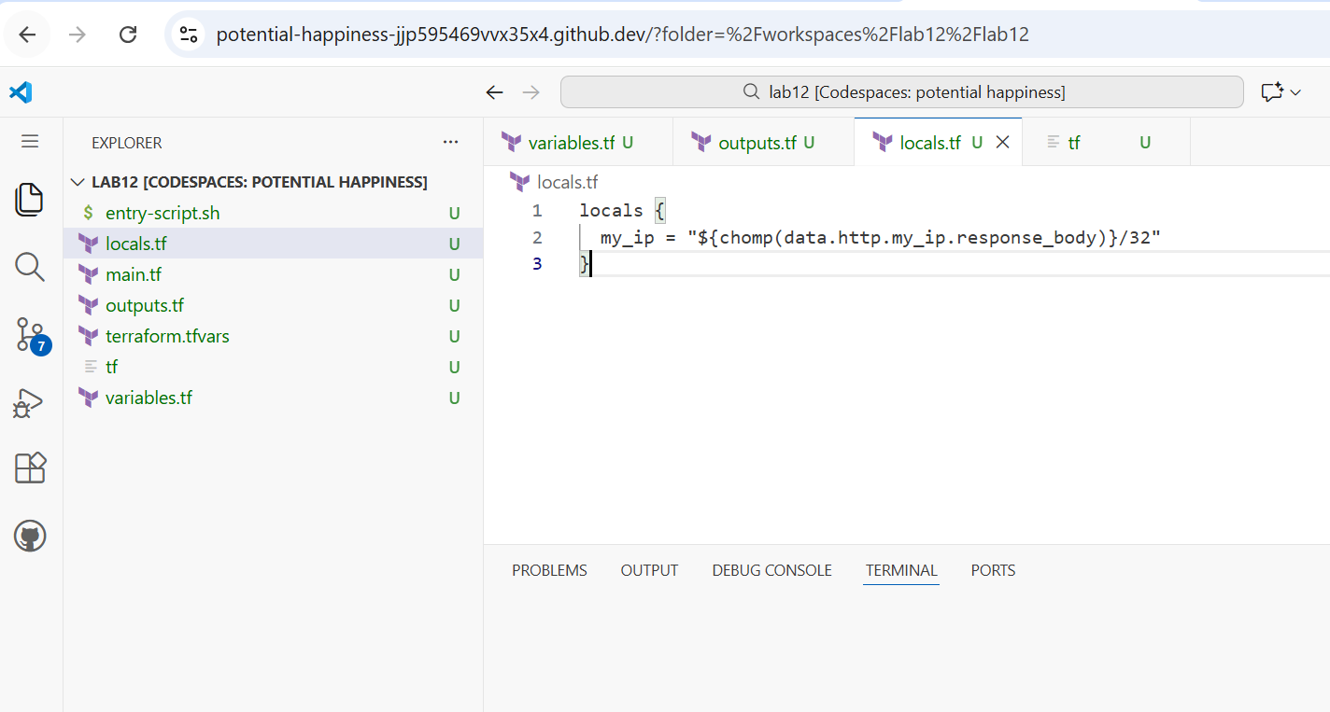

Create terraform.tfvars with the following content:

vpc_cidr_block = "10.0.0.0/16"

subnet_cidr_block = "10.0.10.0/24"

availability_zone = "me-central-1a"

env_prefix = "dev"

instance_type = "t3.micro"

public_key = "~/.ssh/id_ed25519.pub"

private_key = "~/.ssh/id_ed25519"

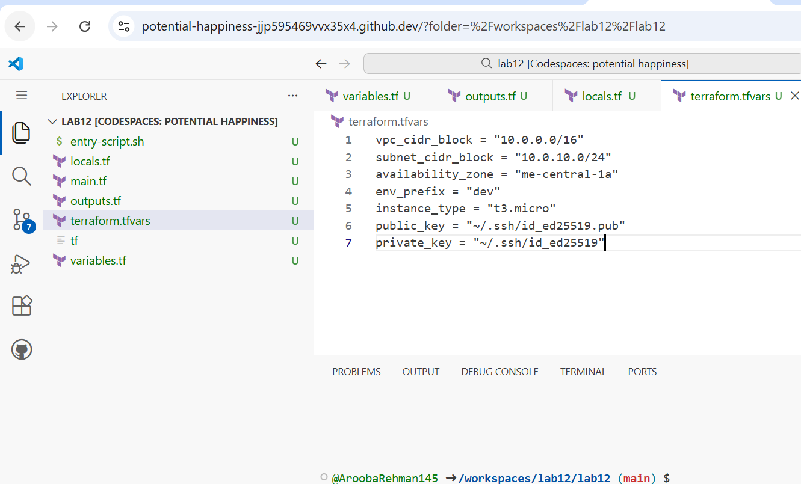

Create main.tf with the following content:

provider "aws" {

shared_config_files = ["~/.aws/config"]

shared_credentials_files = ["~/.aws/credentials"]

}

resource "aws_vpc" "myapp_vpc" {

cidr_block = var.vpc_cidr_block

tags = {

Name = "${var.env_prefix}-vpc"

}

}

resource "aws_subnet" "myapp_subnet_1" {

vpc_id = aws_vpc.myapp_vpc.id

cidr_block = var.subnet_cidr_block

availability_zone = var.availability_zone

tags = {

Name = "${var.env_prefix}-subnet-1"

}

}

resource "aws_default_route_table" "main_rt" {

default_route_table_id = aws_vpc.myapp_vpc.default_route_table_id

route {

cidr_block = "0.0.0.0/0"

gateway_id = aws_internet_gateway.myapp_igw.id

}

tags = {

Name = "${var.env_prefix}-rt"

}

}

resource "aws_internet_gateway" "myapp_igw" {

vpc_id = aws_vpc.myapp_vpc.id

tags = {

Name = "${var.env_prefix}-igw"

}

}

resource "aws_default_security_group" "default_sg" {

vpc_id = aws_vpc.myapp_vpc.id

ingress {

from_port = 22

to_port = 22

protocol = "tcp"

cidr_blocks = [local.my_ip]

}

ingress {

from_port = 80

to_port = 80

protocol = "tcp"

cidr_blocks = ["0.0.0.0/0"]

}

egress {

from_port = 0

to_port = 0

protocol = "-1"

cidr_blocks = ["0.0.0.0/0"]

prefix_list_ids = []

}

tags = {

Name = "${var.env_prefix}-default-sg"

}

}

resource "aws_key_pair" "ssh-key" {

key_name = "serverkey"

public_key = file(var.public_key)

}

resource "aws_instance" "myapp-server" {

ami = "ami-05524d6658fcf35b6" # Amazon Linux 2023 Kernel 6.1 AMI

instance_type = var.instance_type

subnet_id = aws_subnet.myapp_subnet_1.id

security_groups = [aws_default_security_group.default_sg. id]

availability_zone = var.availability_zone

associate_public_ip_address = true

key_name = aws_key_pair.ssh-key. key_name

user_data = file("./entry-script.sh")

tags = {

Name = "${var.env_prefix}-ec2-instance"

}

}

data "http" "my_ip" {

url = "https://icanhazip.com"

}

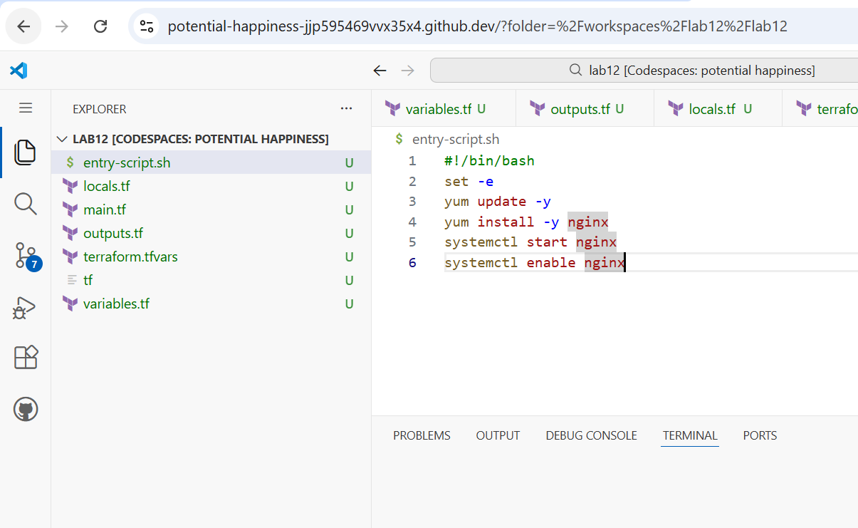

**Generate SSH key pair if not already exists**

ssh-keygen -t ed25519 -f ~/.ssh/id_ed25519 -N ""

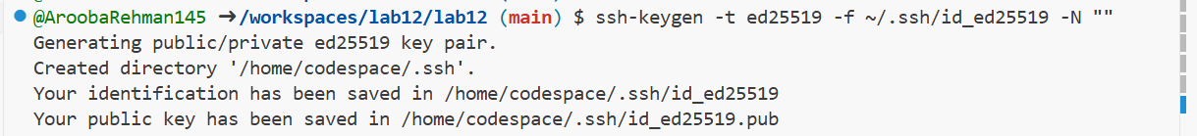

**Initialize:**

terraform init

Firstly downloading terraform:

• **Add the HashiCorp repository:**

sudo apt-get update && sudo apt-get install -y gnupg software-properties-common

wget -O- https://apt.releases.hashicorp.com/gpg | gpg --dearmor | sudo tee /usr/share/keyrings/hashicorp-archive-keyring.gpg > /dev/null

echo "deb [signed-by=/usr/share/keyrings/hashicorp-archive-keyring.gpg] https://apt.releases.hashicorp.com $(lsb_release -cs) main" | sudo tee /etc/apt/sources.list.d/hashicorp.list

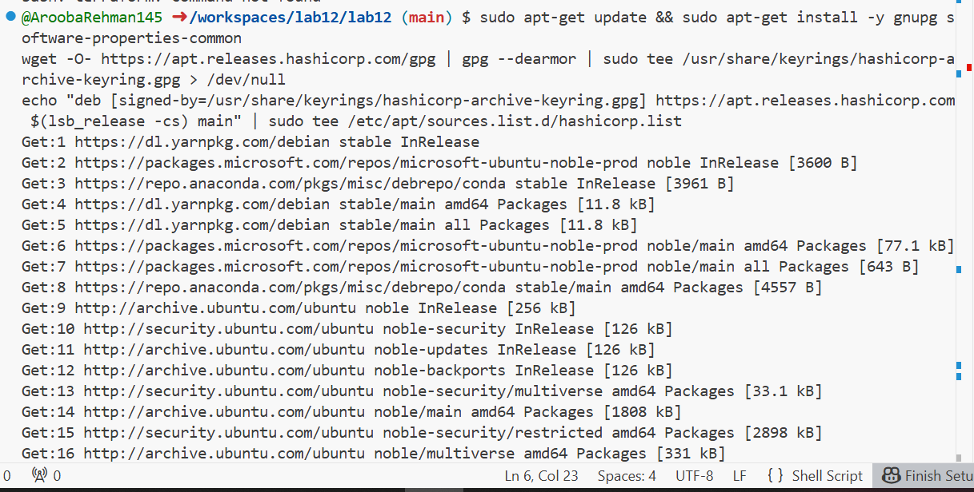

**Install the CLI:**

sudo apt-get update && sudo apt-get install terraform

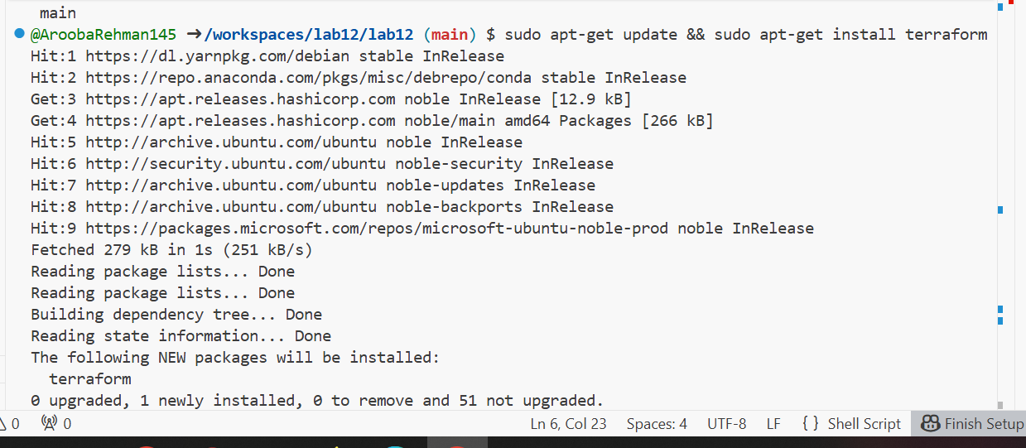

**Verify the installation:**

terraform -version



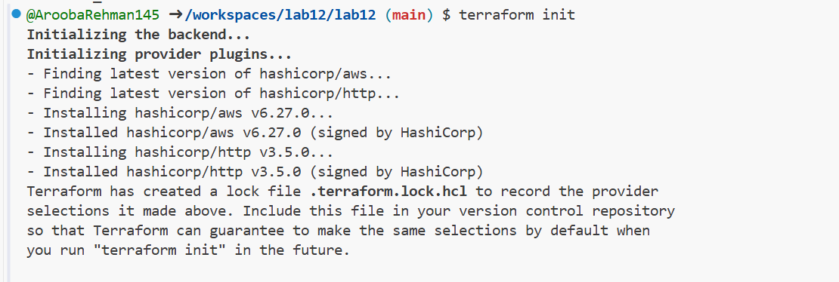

**Apply:**

terraform apply -auto-approve

export AWS_ACCESS_KEY_ID="YOUR_ACCESS_KEY"

export AWS_SECRET_ACCESS_KEY="YOUR_SECRET_KEY"

export AWS_DEFAULT_REGION="me-central-1"

### Update your main.tf

Since you are providing the region via the terminal, you should simplify the provider block in your main.tf file. Open the file and ensure the top section looks like this:

provider "aws" {

# Region is now handled by your 'export AWS_DEFAULT_REGION' command

}

resource "aws_vpc" "myapp_vpc" {

cidr_block = var.vpc_cidr_block

tags = {

Name = "${var.env_prefix}-vpc"

}

}

resource "aws_subnet" "myapp_subnet_1" {

vpc_id = aws_vpc.myapp_vpc.id

cidr_block = var.subnet_cidr_block

availability_zone = var.availability_zone

tags = {

Name = "${var.env_prefix}-subnet-1"

}

}

resource "aws_default_route_table" "main_rt" {

default_route_table_id = aws_vpc.myapp_vpc.default_route_table_id

route {

cidr_block = "0.0.0.0/0"

gateway_id = aws_internet_gateway.myapp_igw.id

}

tags = {

Name = "${var.env_prefix}-rt"

}

}

resource "aws_internet_gateway" "myapp_igw" {

vpc_id = aws_vpc.myapp_vpc.id

tags = {

Name = "${var.env_prefix}-igw"

}

}

resource "aws_default_security_group" "default_sg" {

vpc_id = aws_vpc.myapp_vpc.id

ingress {

from_port = 22

to_port = 22

protocol = "tcp"

cidr_blocks = [local.my_ip]

}

ingress {

from_port = 80

to_port = 80

protocol = "tcp"

cidr_blocks = ["0.0.0.0/0"]

}

egress {

from_port = 0

to_port = 0

protocol = "-1"

cidr_blocks = ["0.0.0.0/0"]

}

tags = {

Name = "${var.env_prefix}-default-sg"

}

}

resource "aws_key_pair" "ssh-key" {

key_name = "serverkey"

public_key = file(var.public_key)

}

resource "aws_instance" "myapp-server" {

ami = "ami-05524d6658fcf35b6" # Ensure this AMI exists in me-central-1

instance_type = var.instance_type

subnet_id = aws_subnet.myapp_subnet_1.id

vpc_security_group_ids = [aws_default_security_group.default_sg.id]

availability_zone = var.availability_zone

associate_public_ip_address = true

key_name = aws_key_pair.ssh-key.key_name

user_data = file("./entry-script.sh")

tags = {

Name = "${var.env_prefix}-ec2-instance"

}

}

data "http" "my_ip" {

url = "https://icanhazip.com"

}

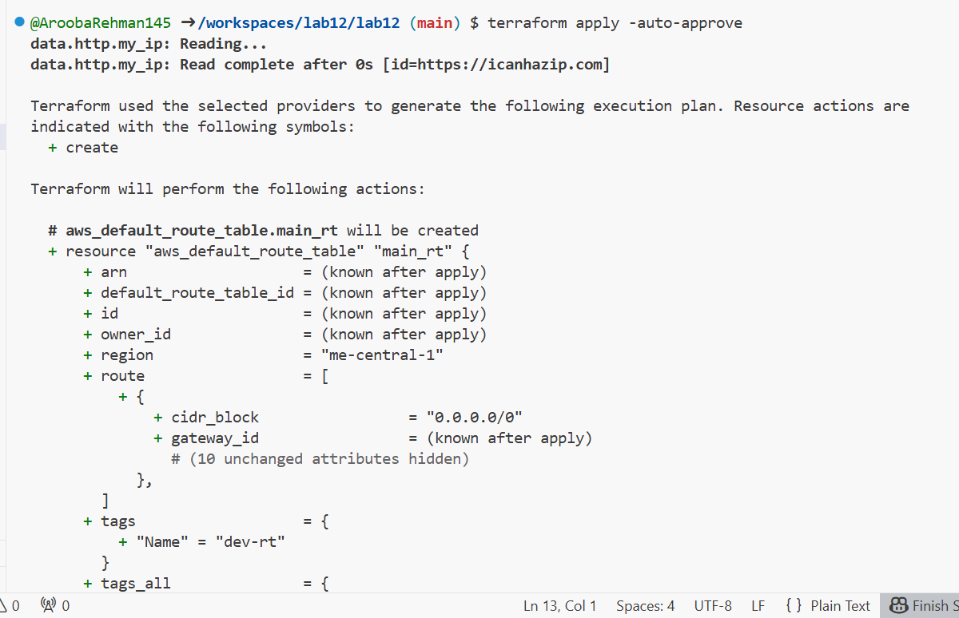

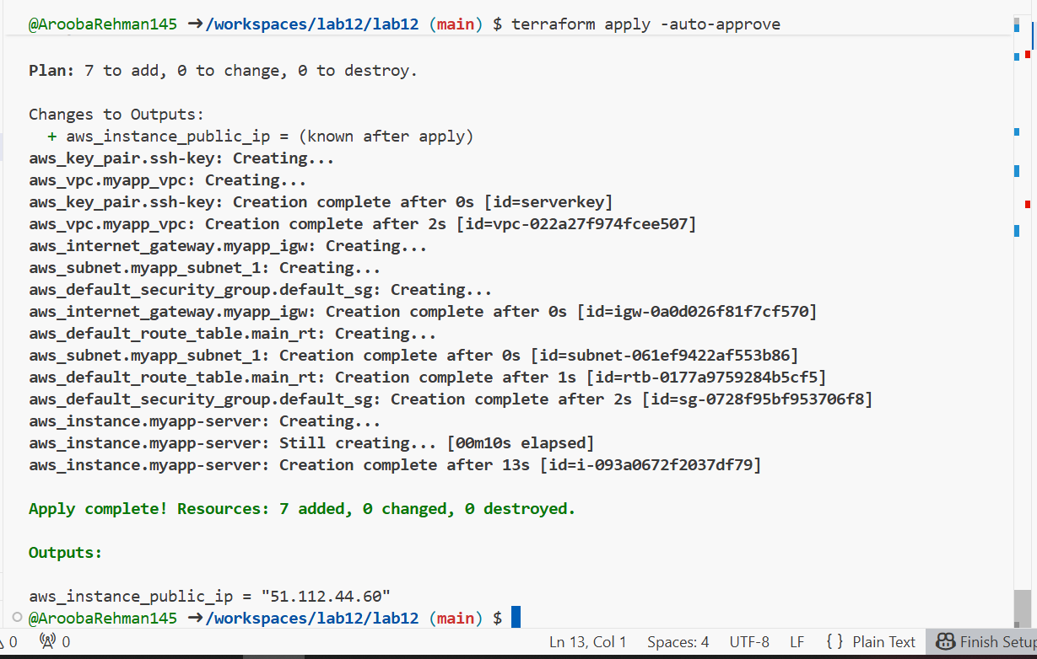

**Get IP:**

terraform output



1. **Test nginx in browser:**

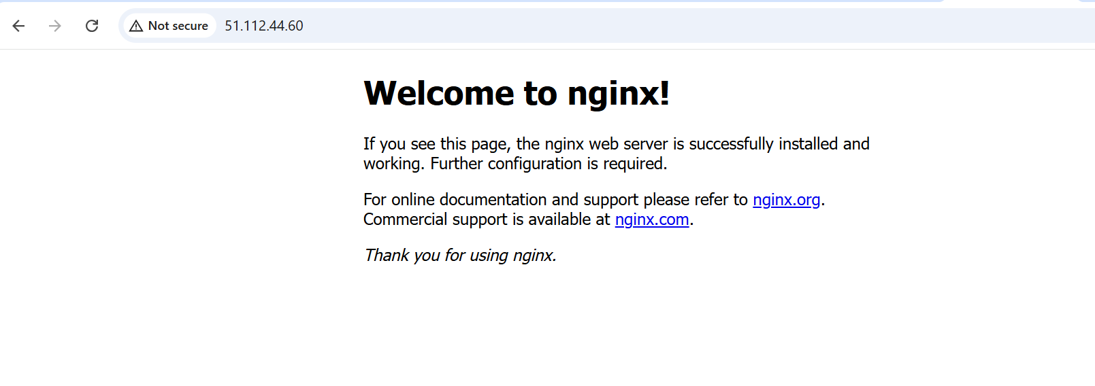

1. **Destroy resources:**

terraform destroy

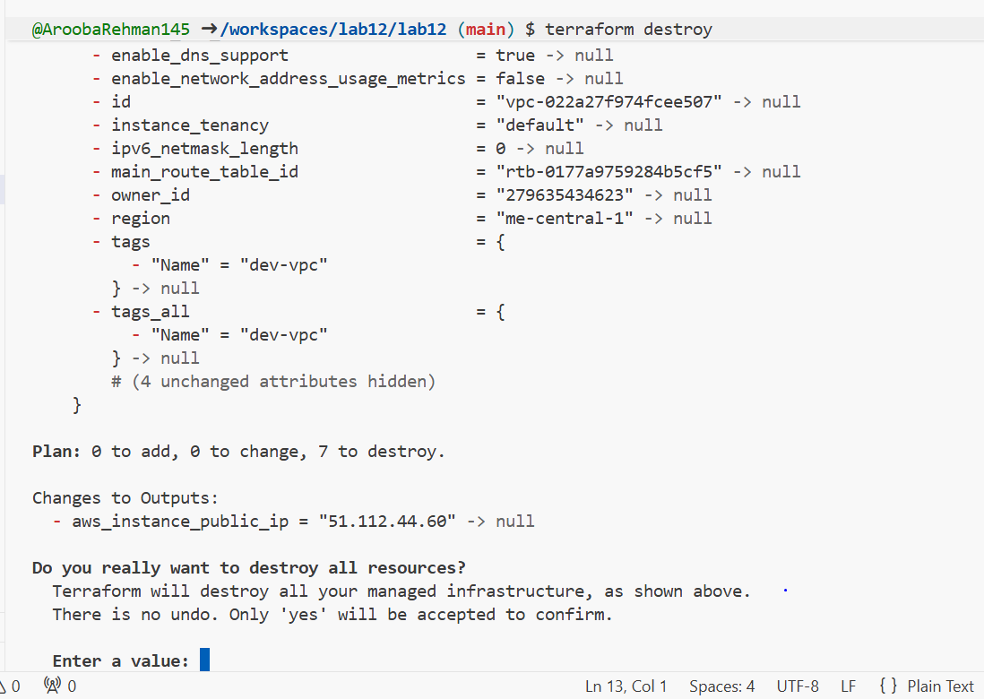

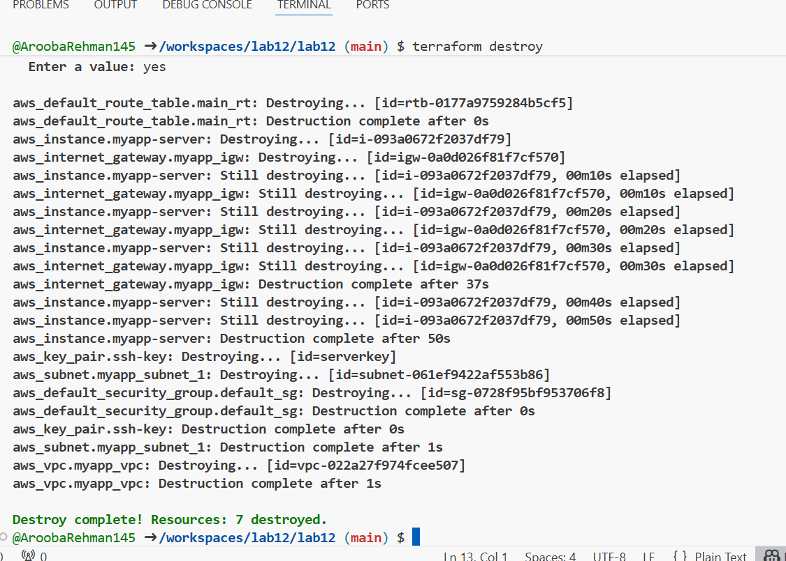

**TASK 2:**

## **Use remote-exec provisioner**

1. Modify the aws_instance resource in main.tf to use remote-exec provisioner:

Updating main.tf file (aws_instance block)

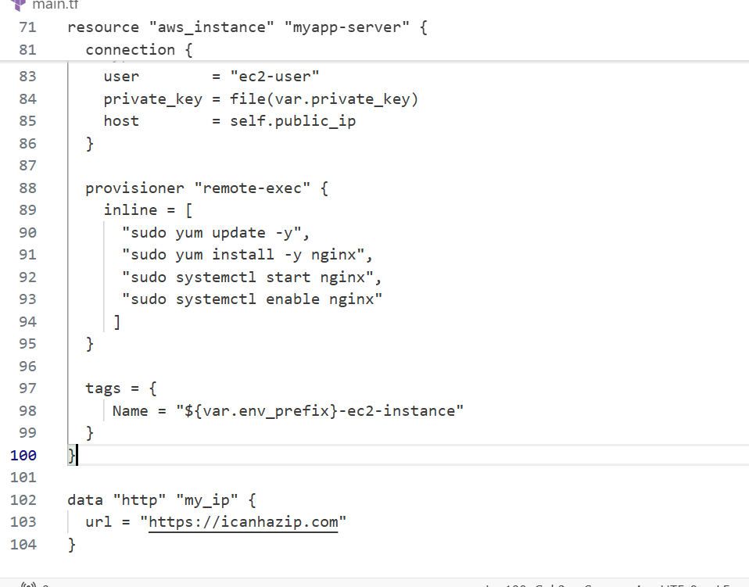

1. Apply the configuration:

terraform apply -auto-approve

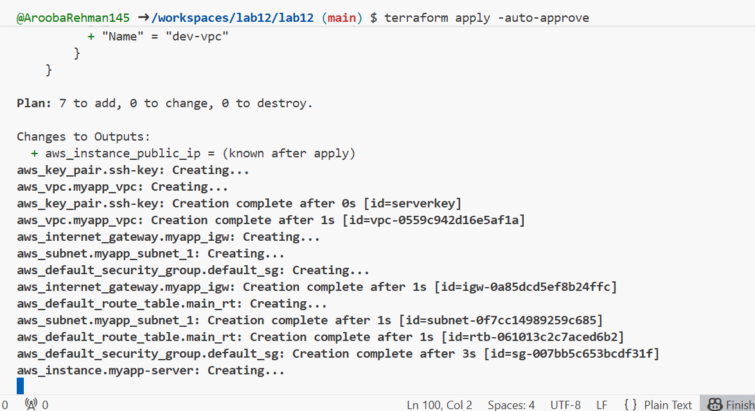

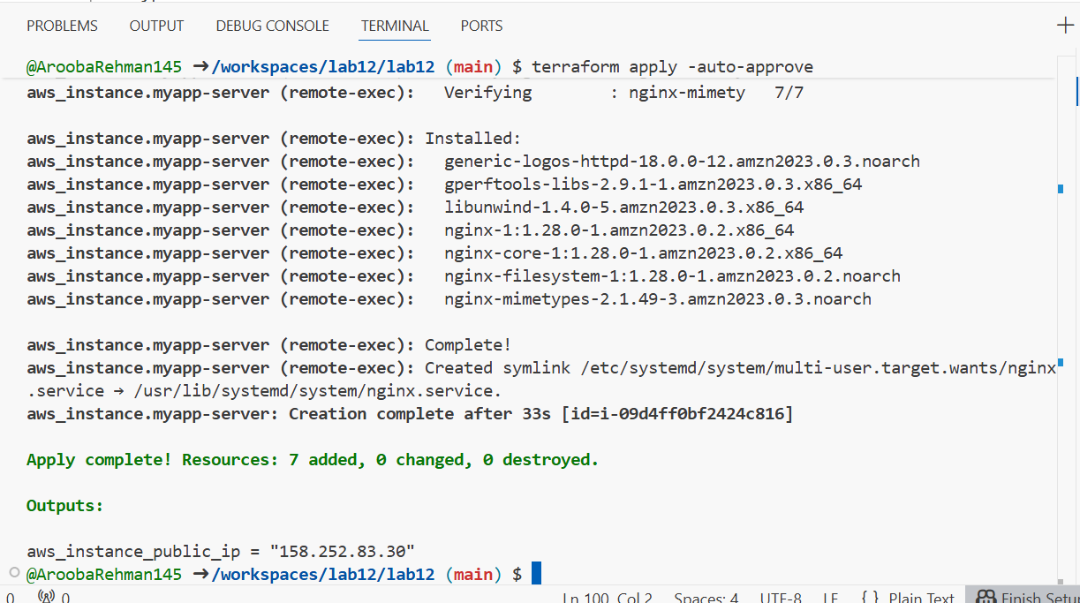

1. Display the output:

terraform output



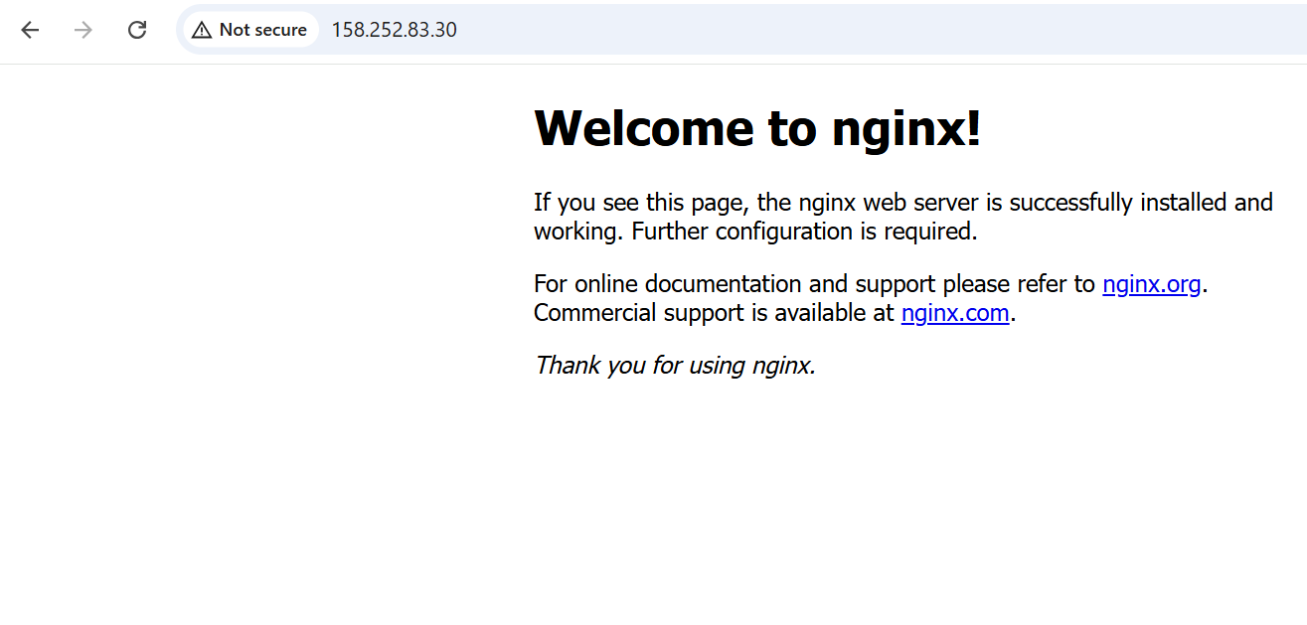

## **Task 3 — Use file and local-exec provisioners**

n this task, you will add the file provisioner to upload the script and the local-exec provisioner to log instance information locally.

1. Modify the aws_instance resource in main.tf to include all three provisioners:

resource "aws_instance" "myapp-server" {

ami = "ami-05524d6658fcf35b6"

instance_type = var.instance_type

subnet_id = aws_subnet.myapp_subnet_1.id

security_groups = [aws_default_security_group.default_sg.id]

availability_zone = var.availability_zone

associate_public_ip_address = true

key_name = aws_key_pair.ssh-key.key_name

connection {

type = "ssh"

user = "ec2-user"

private_key = file(var.private_key)

host = self.public_ip

}

provisioner "file" {

source = "./entry-script.sh"

destination = "/home/ec2-user/entry-script-on-ec2.sh"

}

provisioner "remote-exec" {

inline = [

"sudo chmod +x /home/ec2-user/entry-script-on-ec2.sh",

"sudo /home/ec2-user/entry-script-on-ec2.sh"

]

}

provisioner "local-exec" {

command = <<-EOF

echo Instance ${self.id} with public IP ${self.public_ip} has been created

EOF

}

tags = {

Name = "${var.env_prefix}-ec2-instance"

}

}

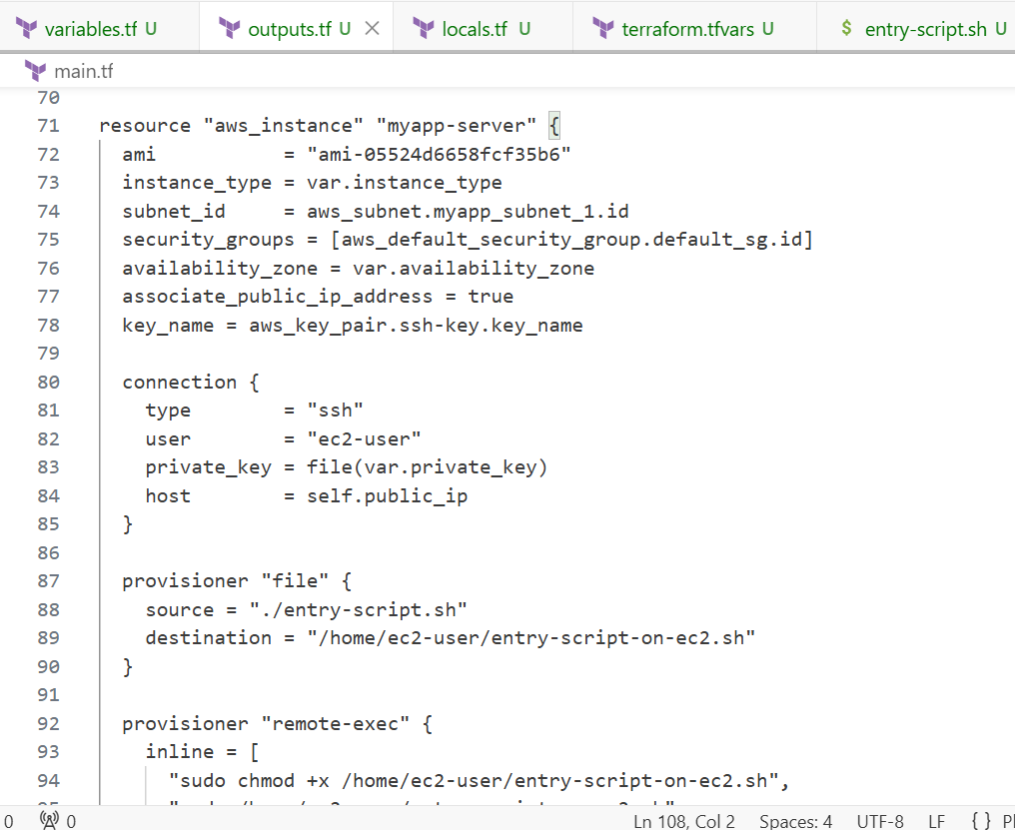

1. Apply the configuration:

terraform apply -auto-approve

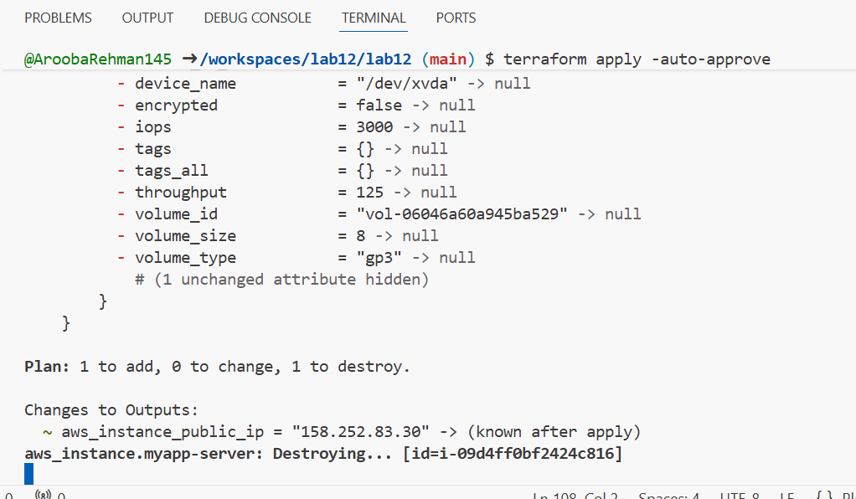

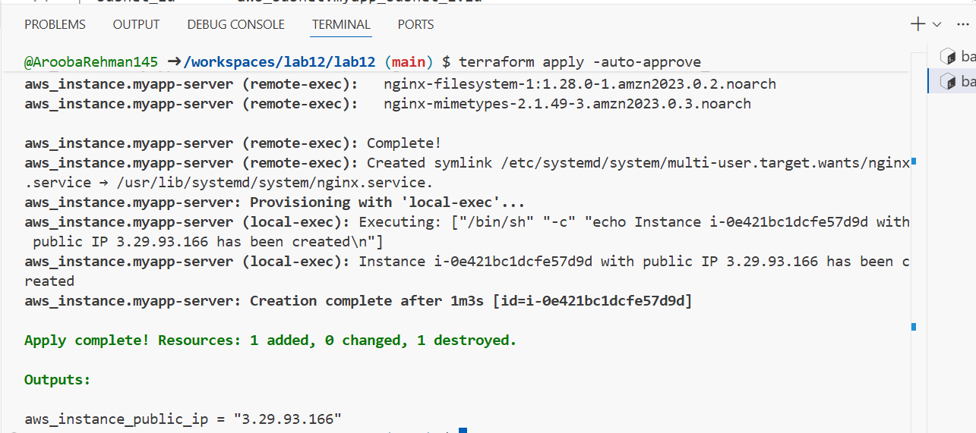

1. Display the output:

terraform output





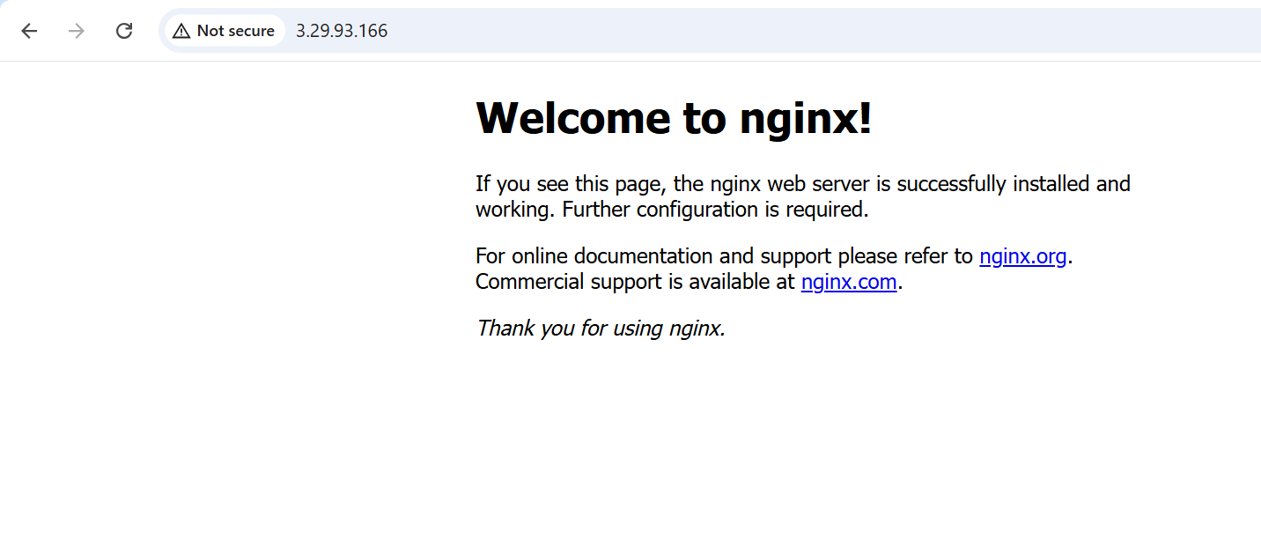

## **Task 4 — Create Terraform modules (subnet module)**

1. Create the module directory structure:

mkdir -p modules/subnet

touch modules/subnet/main.tf

touch modules/subnet/variables.tf

touch modules/subnet/outputs. Tf

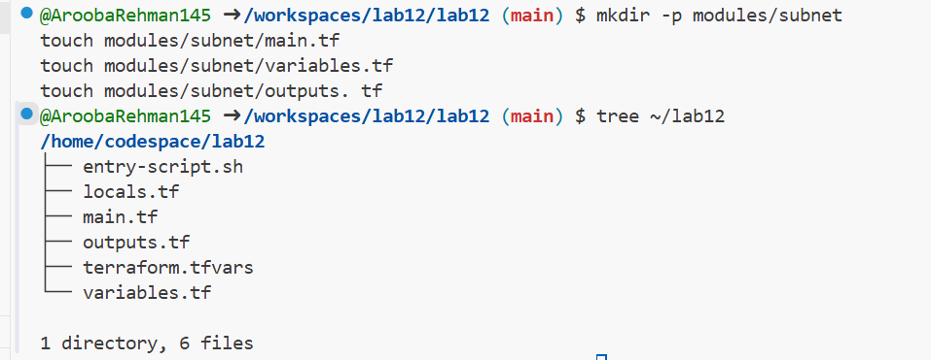

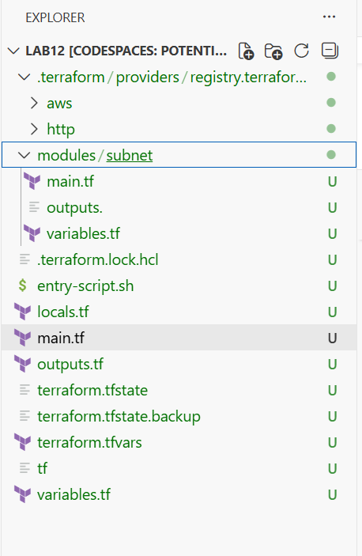

1. Create modules/subnet/variables.tf:

variable "vpc_id" {}

variable "subnet_cidr_block" {}

variable "availability_zone" {}

variable "env_prefix" {}

variable "default_route_table_id" {}

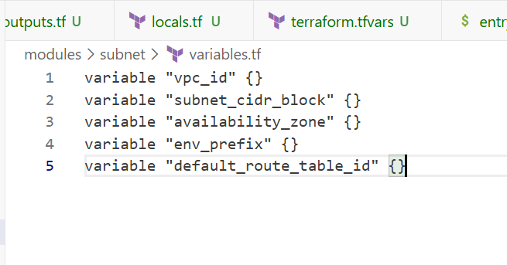

1. Create modules/subnet/main.tf:

resource "aws_subnet" "myapp_subnet_1" {

vpc_id = var.vpc_id

cidr_block = var.subnet_cidr_block

availability_zone = var.availability_zone

map_public_ip_on_launch = true

tags = {

Name = "${var.env_prefix}-subnet-1"

}

}

resource "aws_default_route_table" "main_rt" {

default_route_table_id = var.default_route_table_id

route {

cidr_block = "0.0.0.0/0"

gateway_id = aws_internet_gateway. myapp_igw.id

}

tags = {

Name = "${var.env_prefix}-rt"

}

}

resource "aws_internet_gateway" "myapp_igw" {

vpc_id = var.vpc_id

tags = {

Name = "${var.env_prefix}-igw"

}

}

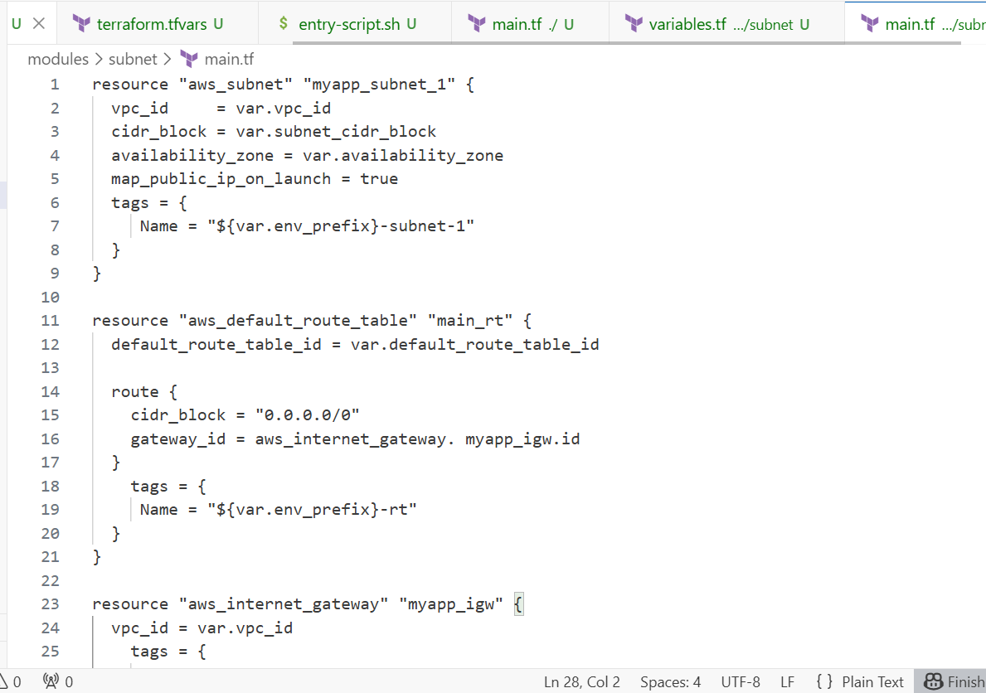

1. Create modules/subnet/outputs.tf:

output "subnet" {

value = aws_subnet.myapp_subnet_1

}

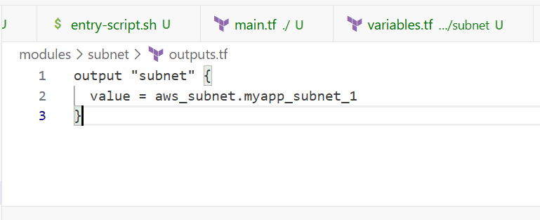

1. Modify the root main.tf to use the subnet module:

Remove the subnet, route table, and internet gateway resources and replace them with:

module "myapp-subnet" {

source = "./modules/subnet"

vpc_id = aws_vpc.myapp_vpc. id

subnet_cidr_block = var.subnet_cidr_block

availability_zone = var.availability_zone

env_prefix = var.env_prefix

default_route_table_id = aws_vpc.myapp_vpc.default_route_table_id

}

And update the instance resource to reference the module output:

resource "aws_instance" "myapp-server" {

# ... other settings ...

subnet_id = module.myapp-subnet. subnet.id

# ... rest of configuration ...

}

Full updated code:

provider "aws" {

# Region is handled by 'export AWS_DEFAULT_REGION'

}

resource "aws_vpc" "myapp_vpc" {

cidr_block = var.vpc_cidr_block

tags = {

Name = "${var.env_prefix}-vpc"

}

}

# --- MODULE CALL START ---

module "myapp-subnet" {

source = "./modules/subnet"

vpc_id = aws_vpc.myapp_vpc.id

subnet_cidr_block = var.subnet_cidr_block

availability_zone = var.availability_zone

env_prefix = var.env_prefix

default_route_table_id = aws_vpc.myapp_vpc.default_route_table_id

}

# --- MODULE CALL END ---

resource "aws_default_security_group" "default_sg" {

vpc_id = aws_vpc.myapp_vpc.id

ingress {

from_port = 22

to_port = 22

protocol = "tcp"

cidr_blocks = [local.my_ip]

}

ingress {

from_port = 80

to_port = 80

protocol = "tcp"

cidr_blocks = ["0.0.0.0/0"]

}

egress {

from_port = 0

to_port = 0

protocol = "-1"

cidr_blocks = ["0.0.0.0/0"]

}

tags = {

Name = "${var.env_prefix}-default-sg"

}

}

resource "aws_key_pair" "ssh-key" {

key_name = "serverkey"

public_key = file(var.public_key)

}

resource "aws_instance" "myapp-server" {

ami = "ami-05524d6658fcf35b6"

instance_type = var.instance_type

# Reference the module output here:

subnet_id = module.myapp-subnet.subnet.id

vpc_security_group_ids = [aws_default_security_group.default_sg.id]

availability_zone = var.availability_zone

associate_public_ip_address = true

key_name = aws_key_pair.ssh-key.key_name

connection {

type = "ssh"

user = "ec2-user"

private_key = file(var.private_key)

host = self.public_ip

}

provisioner "remote-exec" {

inline = [

"sudo yum update -y",

"sudo yum install -y nginx",

"sudo systemctl start nginx",

"sudo systemctl enable nginx"

]

}

tags = {

Name = "${var.env_prefix}-ec2-instance"

}

}

data "http" "my_ip" {

url = "https://icanhazip.com"

}

1. Initialize Terraform to download the module:

terraform init

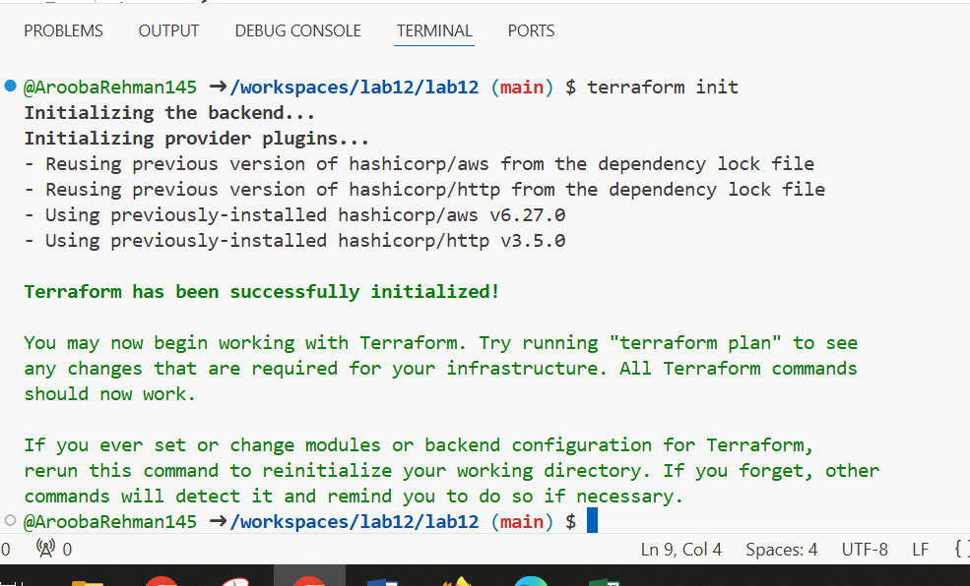

1. Apply the configuration:

terraform apply -auto-approve

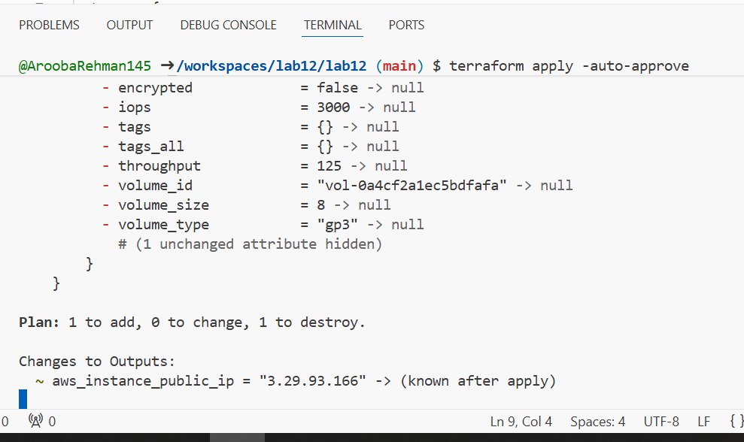

1. Display the output:

terraform output

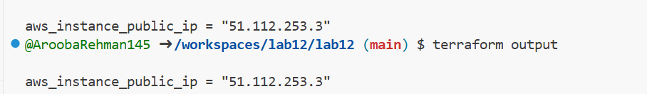

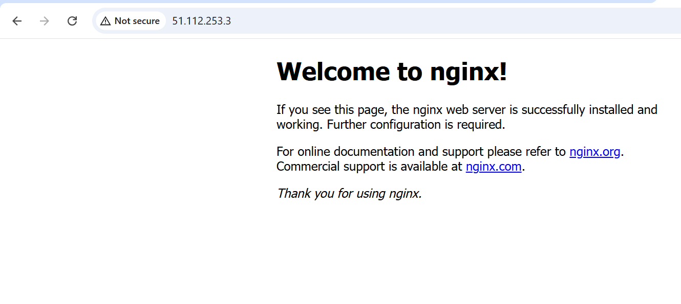

**TASK 5:**

In this task, you will create a reusable webserver module for EC2 instances.

1. Create the webserver module directory structure:

mkdir -p modules/webserver

touch modules/webserver/main.tf

touch modules/webserver/variables.tf

touch modules/webserver/outputs.tf



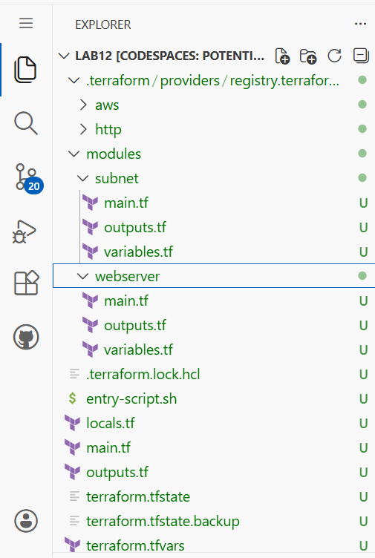

1. Create modules/webserver/variables.tf:

variable "env_prefix" {}

variable "instance_type" {}

variable "availability_zone" {}

variable "public_key" {}

variable "my_ip" {}

variable "vpc_id" {}

variable "subnet_id" {}

variable "script_path" {}

variable "instance_suffix" {}

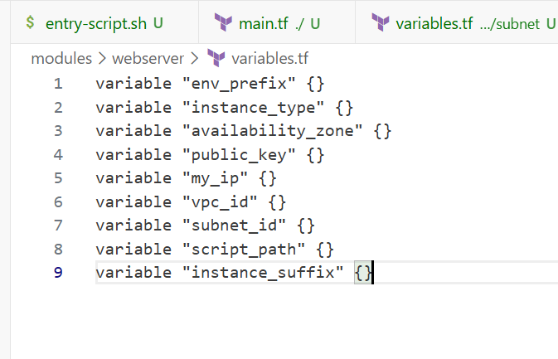

1. Create modules/webserver/main.tf:

resource "aws_security_group" "web_sg" {

vpc_id = var.vpc_id

name = "${var.env_prefix}-web-sg-${var.instance_suffix}"

description = "Security group for web server allowing HTTP, HTTPS and SSH"

ingress {

from_port = 22

to_port = 22

protocol = "tcp"

cidr_blocks = [var.my_ip]

}

ingress {

from_port = 443

to_port = 443

protocol = "tcp"

cidr_blocks = ["0.0.0.0/0"]

}

ingress {

from_port = 80

to_port = 80

protocol = "tcp"

cidr_blocks = ["0.0.0.0/0"]

}

egress {

from_port = 0

to_port = 0

protocol = "-1"

cidr_blocks = ["0.0.0.0/0"]

prefix_list_ids = []

}

tags = {

Name = "${var.env_prefix}-default-sg"

}

}

resource "aws_key_pair" "ssh-key" {

key_name = "${var.env_prefix}-serverkey-${var.instance_suffix}"

public_key = file(var.public_key)

}

resource "aws_instance" "myapp-server" {

ami = "ami-05524d6658fcf35b6" # Amazon Linux 2023 Kernel 6.1 AMI

instance_type = var. instance_type

subnet_id = var.subnet_id

security_groups = [aws_security_group.web_sg.id]

availability_zone = var. availability_zone

associate_public_ip_address = true

key_name = aws_key_pair.ssh-key.key_name

user_data = file(var.script_path)

tags = {

Name = "${var.env_prefix}-ec2-instance-${var.instance_suffix}"

}

}

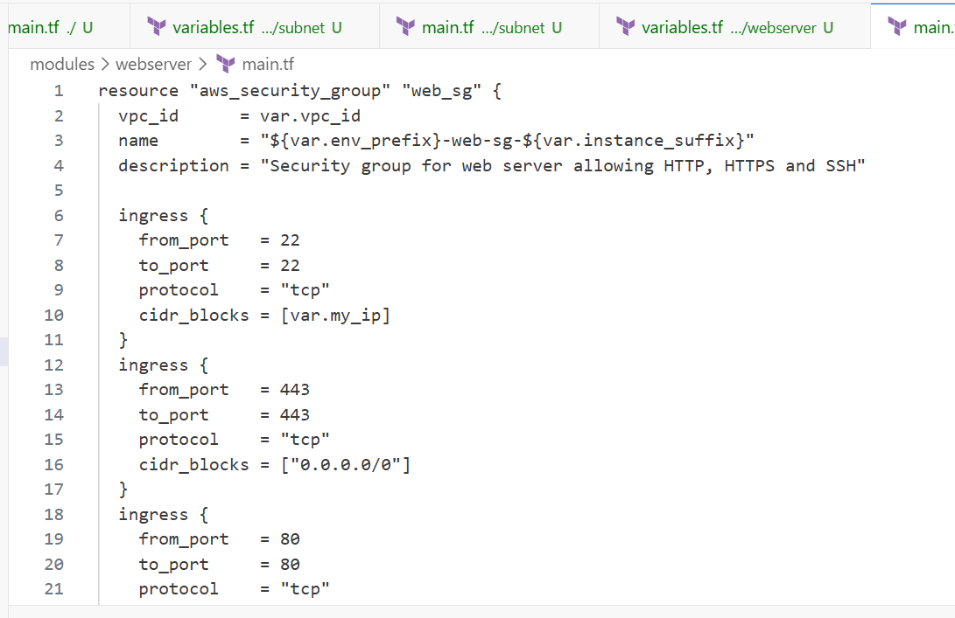

1. Create modules/webserver/outputs.tf:

output "aws_instance" {

value = aws_instance.myapp-server

}

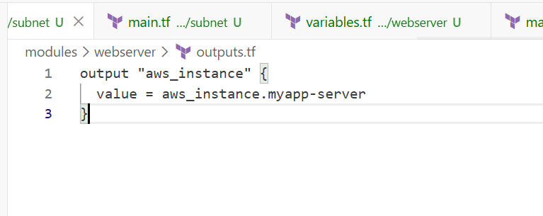

1. Modify the root main.tf:

Remove the security group, key pair, and instance resources. Replace them with:

module "myapp-webserver" {

source = "./modules/webserver"

env_prefix = var.env_prefix

instance_type = var. instance_type

availability_zone = var.availability_zone

public_key = var.public_key

my_ip = local.my_ip

vpc_id = aws_vpc.myapp_vpc.id

subnet_id = module.myapp-subnet.subnet.id

script_path = "./entry-script.sh"

instance_suffix = "0"

}

* provider "aws" {
* # Authentication is handled by terminal 'export' commands for Access Key, Secret Key, and Region.
* }
* # The VPC remains in the root main.tf as the foundation for both modules.
* resource "aws_vpc" "myapp_vpc" {
* cidr_block = var.vpc_cidr_block
* tags = {
* Name = "${var.env_prefix}-vpc"
* }
* }
* # --- Task 3: Subnet Module Call ---
* module "myapp-subnet" {
* source = "./modules/subnet"
* vpc_id = aws_vpc.myapp_vpc.id
* subnet_cidr_block = var.subnet_cidr_block
* availability_zone = var.availability_zone
* env_prefix = var.env_prefix
* default_route_table_id = aws_vpc.myapp_vpc.default_route_table_id
* }
* # --- Task 3: Webserver Module Call ---
* module "myapp-webserver" {
* source = "./modules/webserver"
* env_prefix = var.env_prefix
* instance_type = var.instance_type
* availability_zone = var.availability_zone
* public_key = var.public_key
* my_ip = local.my_ip
* vpc_id = aws_vpc.myapp_vpc.id
* subnet_id = module.myapp-subnet.subnet.id
* script_path = "./entry-script.sh"
* instance_suffix = "0"
* }
* # Data source for local IP remains in root to feed the webserver module.
* data "http" "my_ip" {
* url = "https://icanhazip.com"
* }

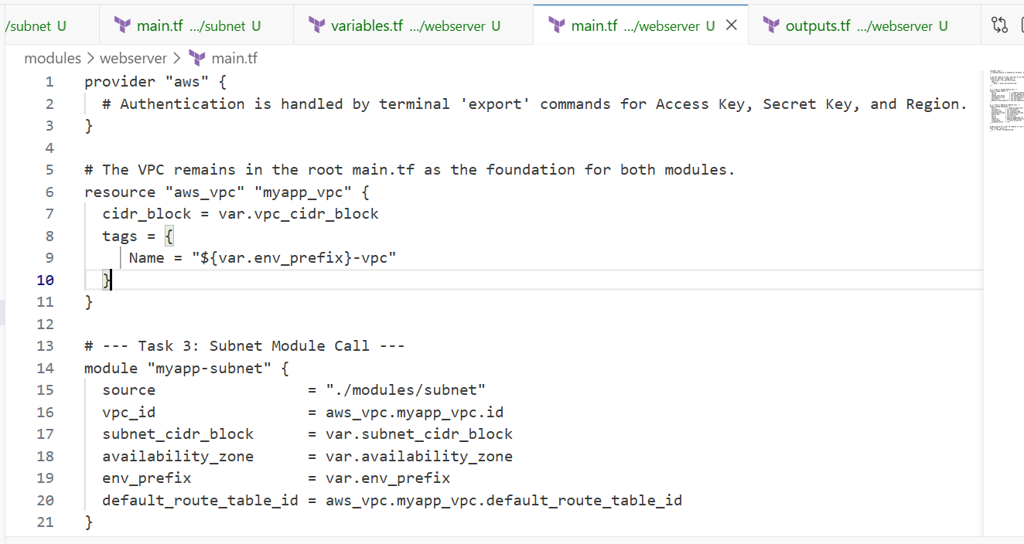

1. Update outputs.tf:

output "webserver_public_ip" {

value = module.myapp-webserver.aws_instance.public_ip

}

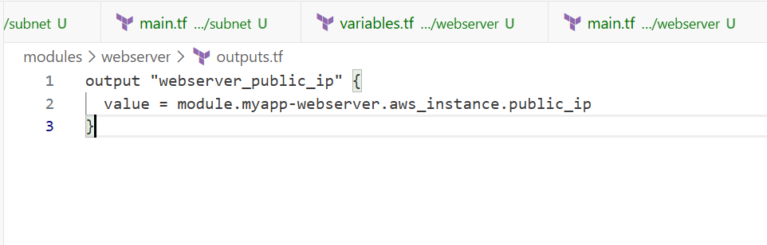

1. Initialize Terraform:

terraform init

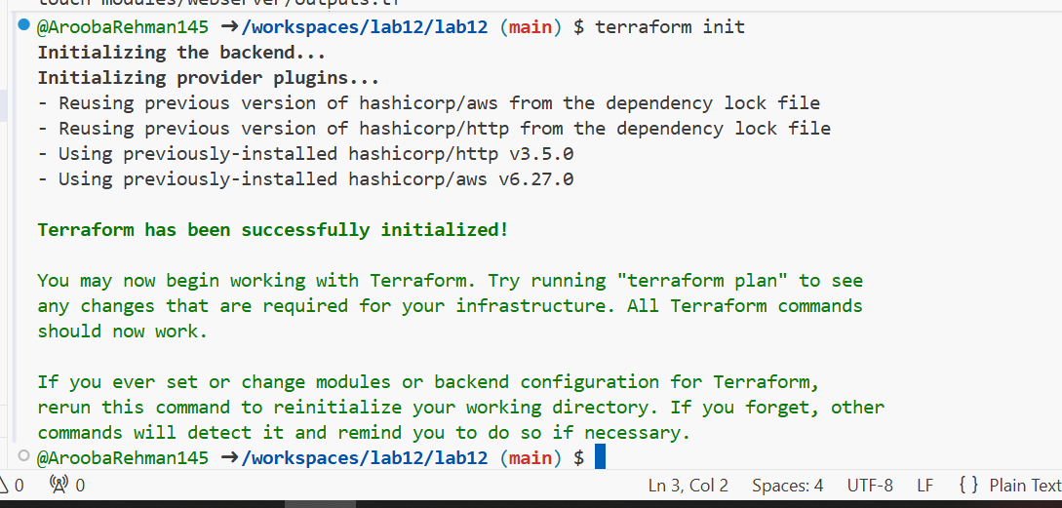

1. Apply the configuration:

terraform apply -auto-approve

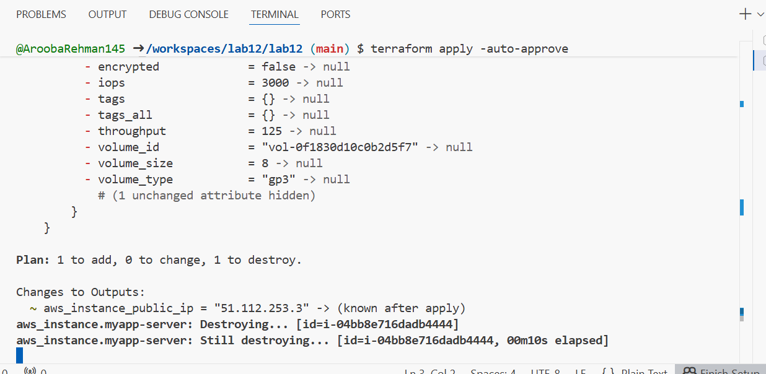

1. Display the output:

terraform output

* 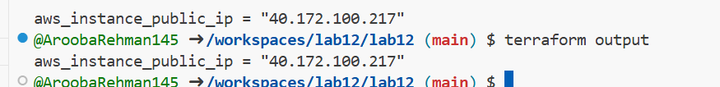

1. Test nginx in browser:

* Open browser and navigate to http://<public-ip>

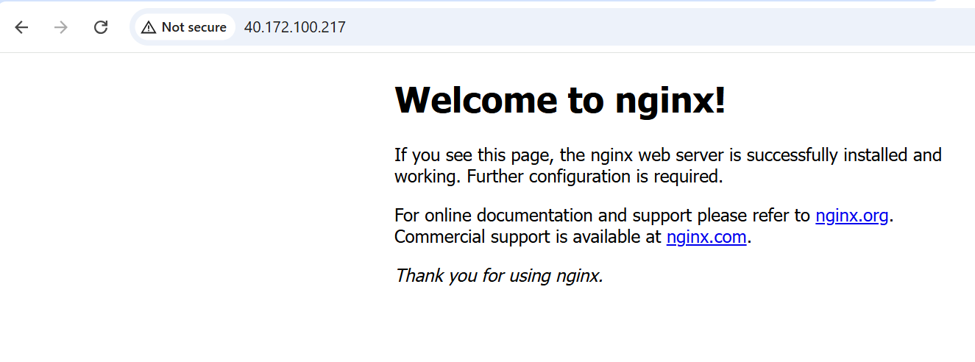

1. Destroy resources:

terraform destroy

* Type yes when prompted.

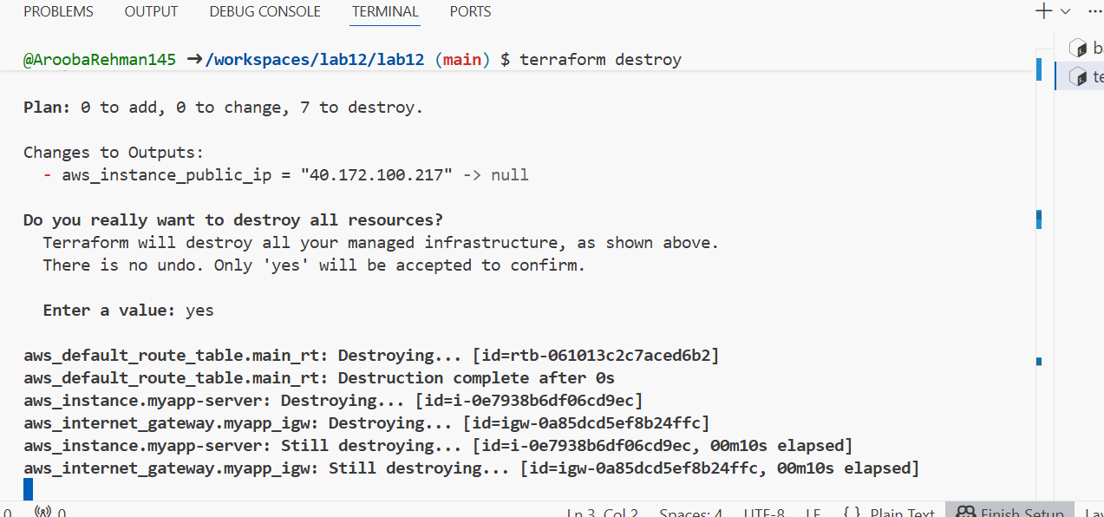

**TASK 6:**

## **Configure HTTPS with self-signed certificates**

In this task, you will configure Nginx to serve traffic over HTTPS using self-signed certificates.

1. Update entry-script.sh with SSL configuration:

#!/bin/bash

set -e

yum update -y

yum install -y nginx

systemctl start nginx

systemctl enable nginx

# Create directories for SSL certificates if they don't exist

mkdir -p /etc/ssl/private

mkdir -p /etc/ssl/certs

# Get IMDSv2 token

TOKEN=$(curl -s -X PUT "http://169.254.169.254/latest/api/token" \

-H "X-aws-ec2-metadata-token-ttl-seconds: 21600")

# Get current public IP

PUBLIC_IP=$(curl -s -H "X-aws-ec2-metadata-token: $TOKEN" \

http://169.254.169.254/latest/meta-data/public-ipv4)

PUBLIC_HOSTNAME=$(curl -s -H "X-aws-ec2-metadata-token: $TOKEN" \

http://169.254.169.254/latest/meta-data/public-hostname)

# Generate self-signed certificate with dynamic IP

openssl req -x509 -nodes -days 365 -newkey rsa:2048 \

-keyout /etc/ssl/private/selfsigned.key \

-out /etc/ssl/certs/selfsigned.crt \

-subj "/CN=$PUBLIC_IP" \

-addext "subjectAltName=IP:$PUBLIC_IP" \

-addext "basicConstraints=CA:FALSE" \

-addext "keyUsage=digitalSignature,keyEncipherment" \

-addext "extendedKeyUsage=serverAuth"

echo "Self-signed certificate created for IP: $PUBLIC_IP"

# Backup existing nginx. conf

cp /etc/nginx/nginx.conf /etc/nginx/nginx.conf.bak

# Overwrite nginx.conf with the desired content

cat <<EOF > /etc/nginx/nginx.conf

user nginx;

worker_processes auto;

error_log /var/log/nginx/error.log notice;

pid /run/nginx. pid;

events {

worker_connections 1024;

}

http {

log_format main '\$remote_addr - \$remote_user [\$time_local] "\$request" '

'\$status \$body_bytes_sent "\$http_referer" '

'"\$http_user_agent" "\$http_x_forwarded_for"';

access_log /var/log/nginx/access.log main;

sendfile on;

tcp_nopush on;

keepalive_timeout 65;

types_hash_max_size 4096;

include /etc/nginx/mime.types;

default_type application/octet-stream;

upstream backend_servers {

server 158.252.94.241:80;

server 158.252.94.242:80 backup;

}

server {

listen 443 ssl;

server_name $PUBLIC_IP;

ssl_certificate /etc/ssl/certs/selfsigned. crt;

ssl_certificate_key /etc/ssl/private/selfsigned.key;

location / {

root /usr/share/nginx/html;

index index.html;

# proxy_pass http://158.252.94.241:80;

# proxy_pass http://backend_servers;

}

}

server {

listen 80;

server_name _;

return 301 https://\$host\$request_uri;

}

}

EOF

# Test and restart Nginx

systemctl restart nginx

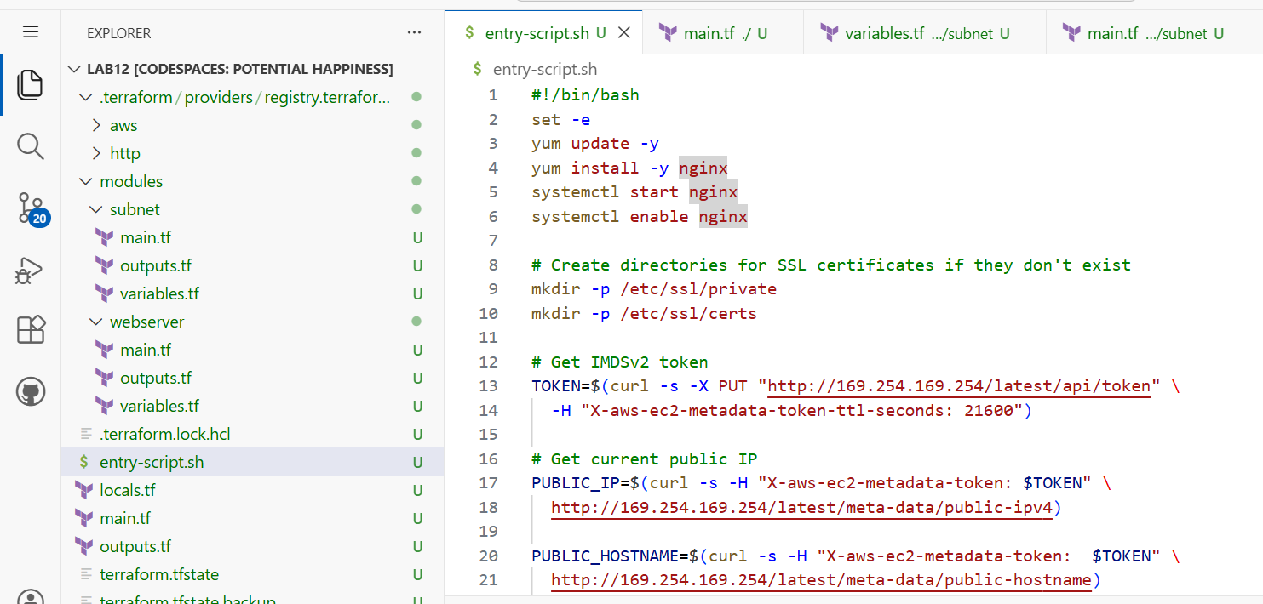

1. Apply the configuration:

terraform apply -auto-approve

as error encountered:

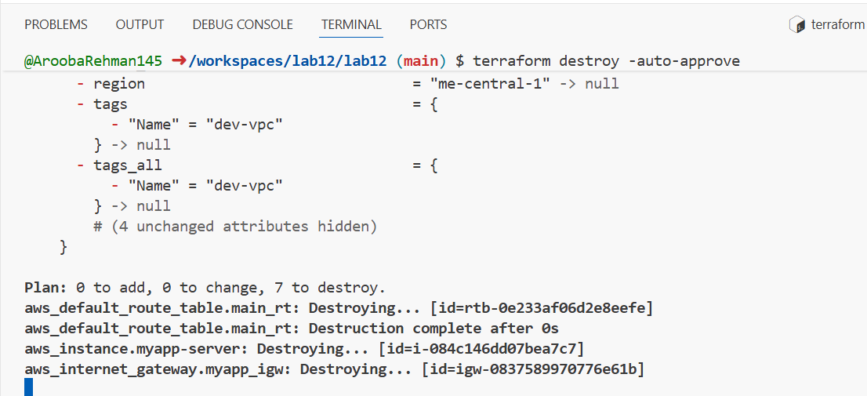

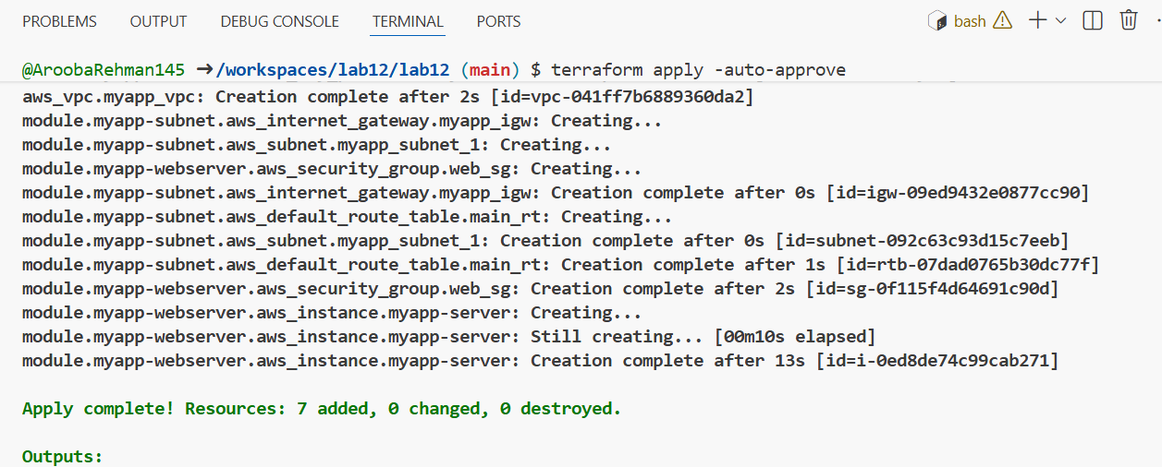

1. Display the output:

terraform output

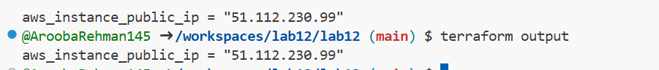

1. Test HTTPS in browser:

* Open browser and navigate to https://<public-ip>
* You will see a warning: "Warning: Potential Security Risk Ahead"
* Click "Advanced" button
* Click "Accept the Risk and Continue"

Corrected root main.tf code:

provider "aws" {

# Authentication is handled via terminal export commands

}

# Foundation VPC

resource "aws_vpc" "myapp_vpc" {

cidr_block = var.vpc_cidr_block

tags = {

Name = "${var.env_prefix}-vpc"

}

}

# Subnet Module Call

module "myapp-subnet" {

source = "./modules/subnet"

vpc_id = aws_vpc.myapp_vpc.id

subnet_cidr_block = var.subnet_cidr_block

availability_zone = var.availability_zone

env_prefix = var.env_prefix

default_route_table_id = aws_vpc.myapp_vpc.default_route_table_id

}

# Webserver Module Call (Task 6 HTTPS Configuration)

module "myapp-webserver" {

source = "./modules/webserver"

env_prefix = var.env_prefix

instance_type = var.instance_type

availability_zone = var.availability_zone

public_key = var.public_key

my_ip = local.my_ip

vpc_id = aws_vpc.myapp_vpc.id

subnet_id = module.myapp-subnet.subnet.id

script_path = "./entry-script.sh"

instance_suffix = "0"

}

# Data source for SSH security

data "http" "my_ip" {

url = "https://icanhazip.com"

}

Webserver main.tf:

resource "aws_security_group" "web_sg" {

vpc_id = var.vpc_id

name = "${var.env_prefix}-web-sg-${var.instance_suffix}"

ingress {

from_port = 22

to_port = 22

protocol = "tcp"

cidr_blocks = [var.my_ip]

}

ingress {

from_port = 80

to_port = 80

protocol = "tcp"

cidr_blocks = ["0.0.0.0/0"]

}

# Port 443 is required for Task 6 HTTPS

ingress {

from_port = 443

to_port = 443

protocol = "tcp"

cidr_blocks = ["0.0.0.0/0"]

}

egress {

from_port = 0

to_port = 0

protocol = "-1"

cidr_blocks = ["0.0.0.0/0"]

}

}

resource "aws_key_pair" "ssh-key" {

key_name = "${var.env_prefix}-serverkey-${var.instance_suffix}"

public_key = file(var.public_key)

}

resource "aws_instance" "myapp-server" {

ami = "ami-05524d6658fcf35b6"

instance_type = var.instance_type

subnet_id = var.subnet_id

vpc_security_group_ids = [aws_security_group.web_sg.id]

availability_zone = var.availability_zone

associate_public_ip_address = true

key_name = aws_key_pair.ssh-key.key_name

# Reliable script execution for Task 6

user_data = file(var.script_path)

tags = {

Name = "${var.env_prefix}-ec2-instance-${var.instance_suffix}"

}

}

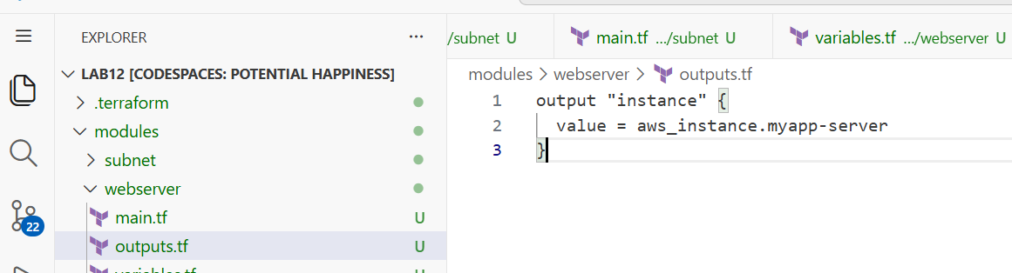

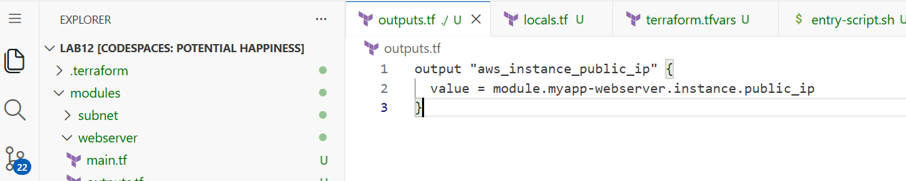

Entry.script:

#!/bin/bash

set -e

# Update and Install Nginx

yum update -y

yum install -y nginx

# SSL setup

mkdir -p /etc/ssl/private /etc/ssl/certs

TOKEN=$(curl -s -X PUT "http://169.254.169.254/latest/api/token" -H "X-aws-ec2-metadata-token-ttl-seconds: 21600")

PUBLIC_IP=$(curl -s -H "X-aws-ec2-metadata-token: $TOKEN" http://169.254.169.254/latest/meta-data/public-ipv4)

openssl req -x509 -nodes -days 365 -newkey rsa:2048 \

  -keyout /etc/ssl/private/selfsigned.key \

  -out /etc/ssl/certs/selfsigned.crt \

  -subj "/CN=$PUBLIC_IP" \

  -addext "subjectAltName=IP:$PUBLIC_IP"

# Overwrite Nginx config with valid syntax

cat <<EOF > /etc/nginx/nginx.conf

user nginx;

worker_processes auto;

events { worker_connections 1024; }

http {

    include /etc/nginx/mime.types;

    server {

        listen 443 ssl;

        server_name _;

        ssl_certificate /etc/ssl/certs/selfsigned.crt;

        ssl_certificate_key /etc/ssl/private/selfsigned.key;

        location / {

            root /usr/share/nginx/html;

            index index.html;

        }

    }

    server {

        listen 80;

        server_name _;

        return 301 https://\$host\$request_uri;

    }

}

EOF

systemctl enable nginx

systemctl restart nginx

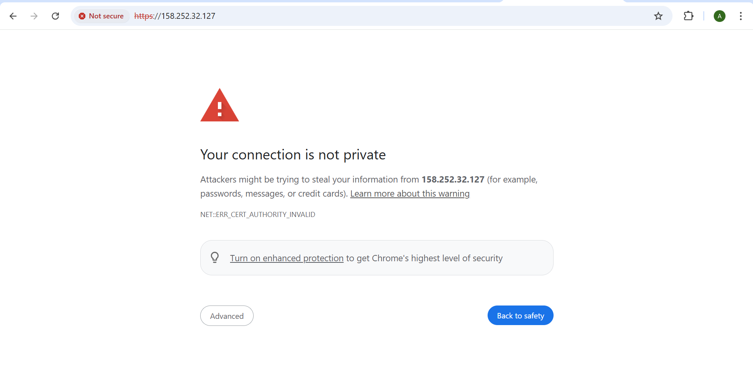

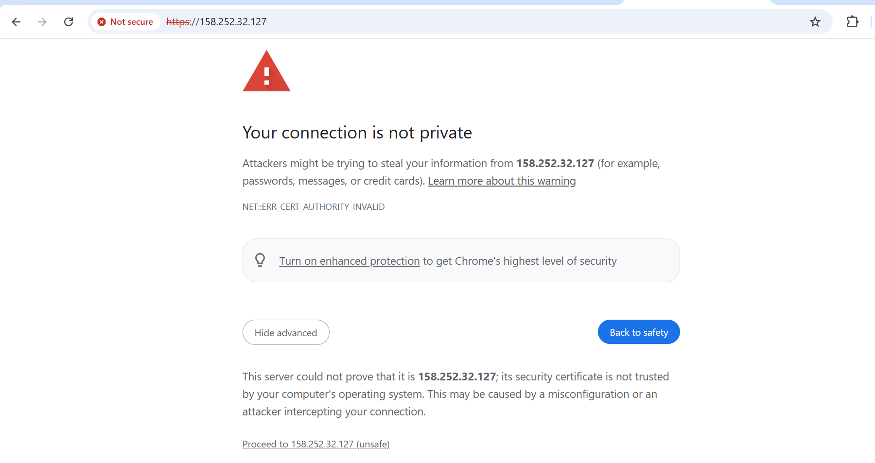

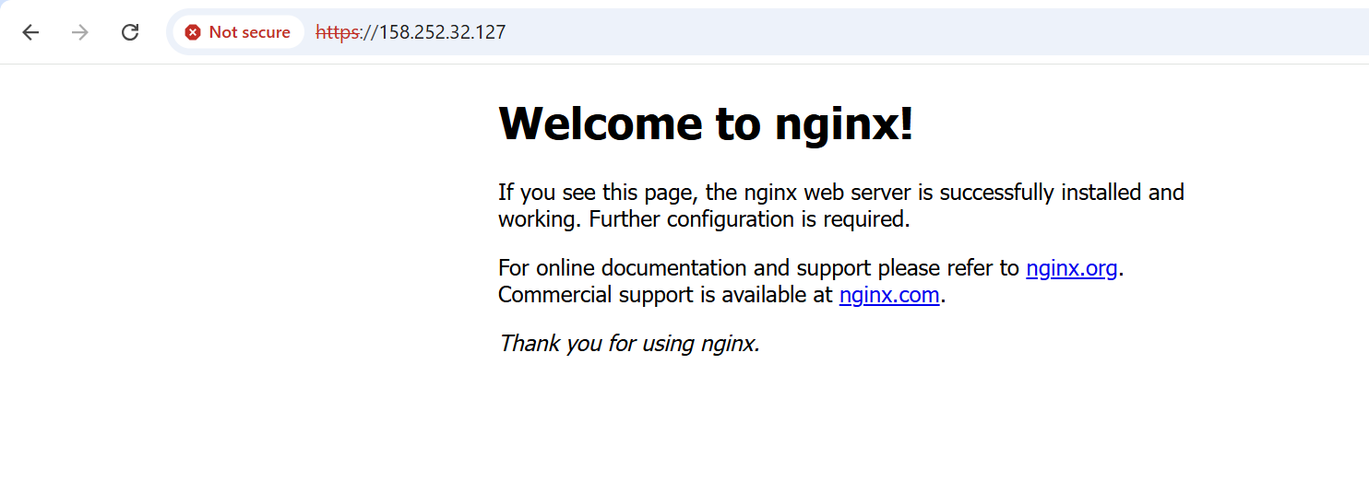

1. Verify HTTP to HTTPS redirect:

* Open browser and navigate to http://<public-ip>
* Verify it redirects to https://<public-ip>

## **Task 7**

## **Configure Nginx as reverse proxy**

In this task, you will create a backend web server and configure Nginx to act as a reverse proxy.

1. Create apache.sh script for backend web server:

#!/bin/bash

yum update -y

yum install httpd -y

systemctl start httpd

systemctl enable httpd

echo "<h1>Welcome to My Web Server</h1>" > /var/www/html/index.html

hostnamectl set-hostname myapp-webserver

echo "<h2>Hostname: $(hostname)</h2>" >> /var/www/html/index.html

TOKEN=$(curl -s -X PUT "http://169.254.169.254/latest/api/token" \

-H "X-aws-ec2-metadata-token-ttl-seconds: 21600")

echo "<h2>Private IP: $(curl -s -H "X-aws-ec2-metadata-token: $TOKEN" http://169.254.169.254/latest/meta-data/local-ipv4)</h2>" >> /var/www/html/index.html

echo "<h2>Public IP: $(curl -s -H "X-aws-ec2-metadata-token: $TOKEN" http://169.254.169.254/latest/meta-data/public-ipv4)</h2>" >> /var/www/html/index.html

echo "<h2>Public DNS: $(curl -s -H "X-aws-ec2-metadata-token: $TOKEN" http://169.254.169.254/latest/meta-data/public-hostname)</h2>" >> /var/www/html/index.html

echo "<h2>Deployed via Terraform</h2>" >> /var/www/html/index. html

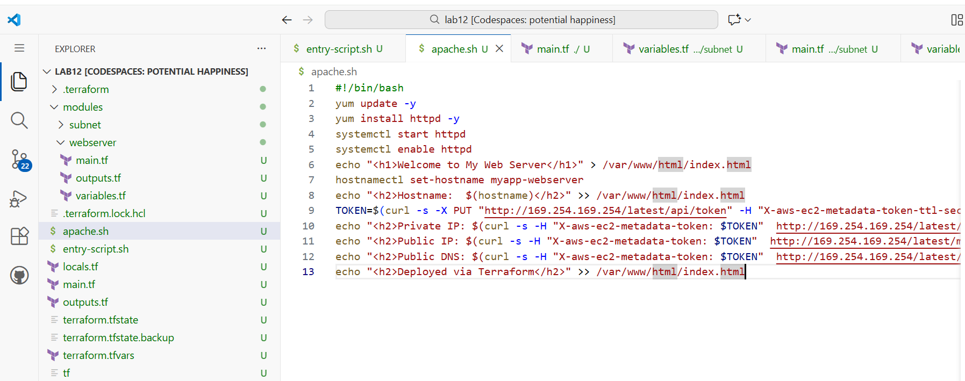

1. Add the backend web server module to main.tf:

module "myapp-web-1" {

source = "./modules/webserver"

env_prefix = var.env_prefix

instance_type = var.instance_type

availability_zone = var.availability_zone

public_key = var. public_key

my_ip = local.my_ip

vpc_id = aws_vpc. myapp_vpc.id

subnet_id = module.myapp-subnet.subnet. id

script_path = "./apache.sh"

instance_suffix = "1"

}

provider "aws" {

# Credentials handled by 'export' commands in terminal

}

# 1. Foundation VPC

resource "aws_vpc" "myapp_vpc" {

cidr_block = var.vpc_cidr_block

tags = {

Name = "${var.env_prefix}-vpc"

}

}

# 2. Subnet Module - Handles IGW and Route Tables

module "myapp-subnet" {

source = "./modules/subnet"

vpc_id = aws_vpc.myapp_vpc.id

subnet_cidr_block = var.subnet_cidr_block

availability_zone = var.availability_zone

env_prefix = var.env_prefix

default_route_table_id = aws_vpc.myapp_vpc.default_route_table_id

}

# 3. Task 6: Nginx Proxy Server (Instance Suffix 0)

module "myapp-webserver" {

source = "./modules/webserver"

env_prefix = var.env_prefix

instance_type = var.instance_type

availability_zone = var.availability_zone

public_key = var.public_key

my_ip = local.my_ip

vpc_id = aws_vpc.myapp_vpc.id

subnet_id = module.myapp-subnet.subnet.id

script_path = "./entry-script.sh" # Task 6 HTTPS Script

instance_suffix = "0"

}

# 4. Task 7: Apache Backend Server (Instance Suffix 1)

module "myapp-web-1" {

source = "./modules/webserver"

env_prefix = var.env_prefix

instance_type = var.instance_type

availability_zone = var.availability_zone

public_key = var.public_key

my_ip = local.my_ip

vpc_id = aws_vpc.myapp_vpc.id

subnet_id = module.myapp-subnet.subnet.id

script_path = "./apache.sh" # Task 7 Apache Script

instance_suffix = "1"

}

# Data source for SSH access security

data "http" "my_ip" {

url = "https://icanhazip.com"

}

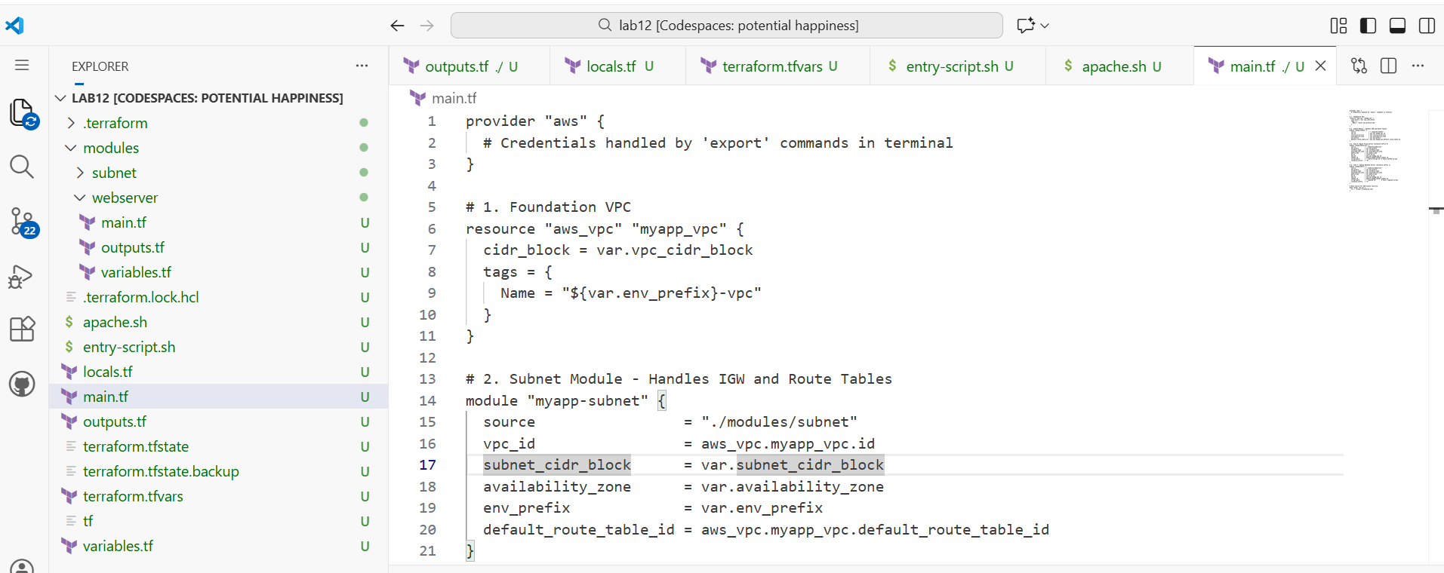

1. Update outputs.tf:

output "aws_web-1_public_ip" {

value = module.myapp-web-1.aws_instance.public_ip

}

output "aws_instance_public_ip" {

description = "Public IP of the Nginx Proxy Server"

value = module.myapp-webserver.instance.public_ip

}

output "aws_web-1_public_ip" {

description = "Public IP of the Apache Backend Server"

value = module.myapp-web-1.instance.public_ip

}

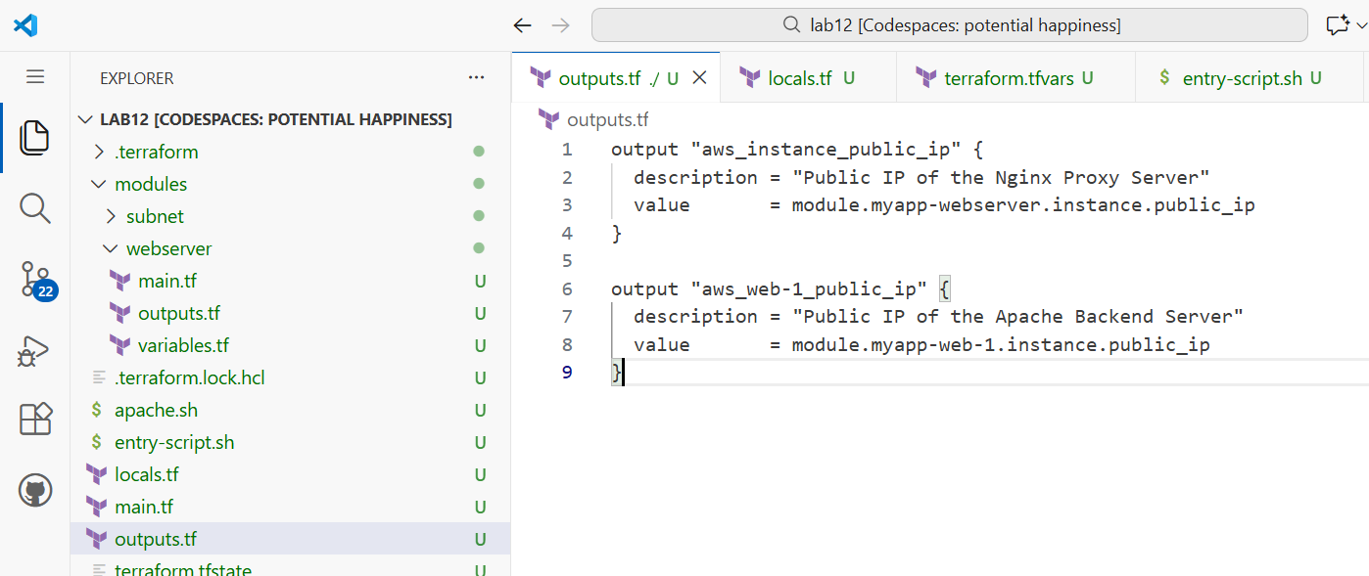

1. Apply the configuration:

terraform apply -auto-approve

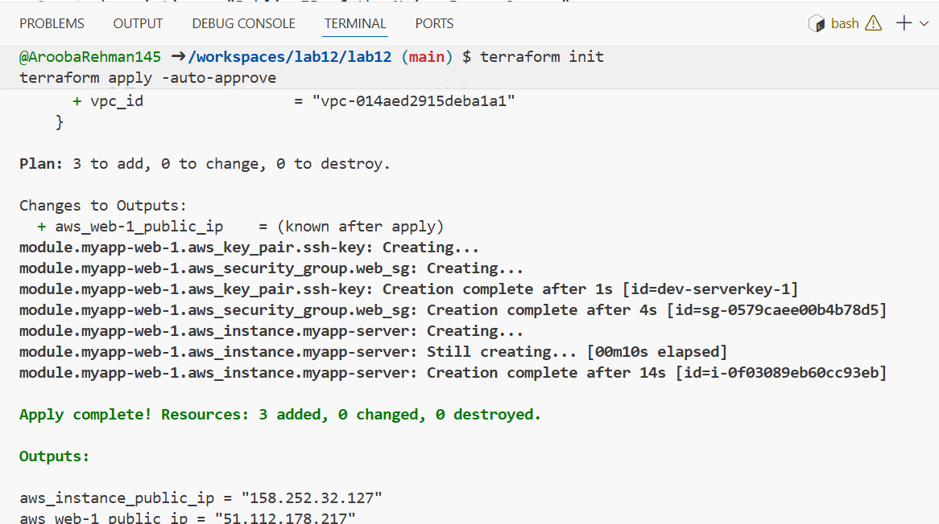

1. Get the outputs:

terraform output

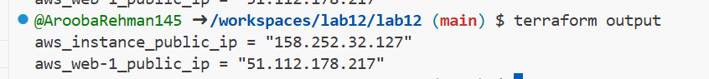

1. SSH into the webserver (Nginx proxy server):

ssh ec2-user@<webserver-public-ip>

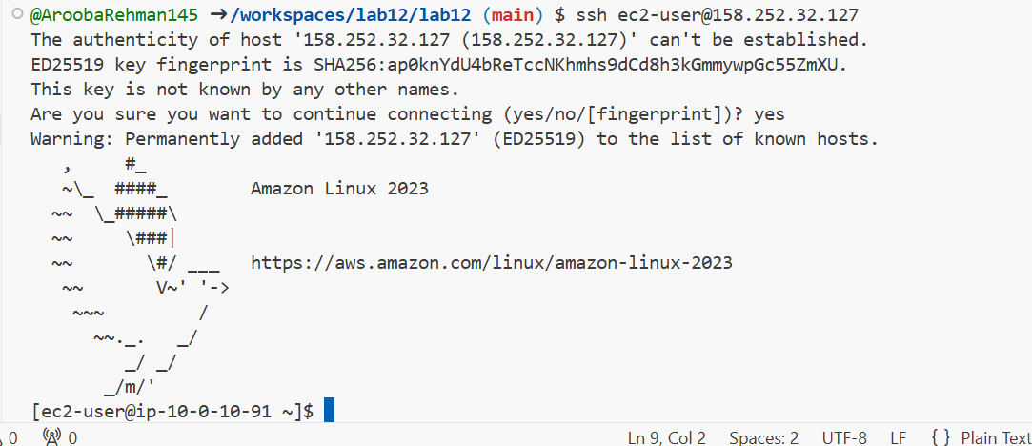

1. Edit the Nginx configuration:

sudo vim /etc/nginx/nginx.conf

Modify the location block to proxy to web-1:

location / {

# root /usr/share/nginx/html;

# index index. html;

proxy_pass http://<web-1-public-ip>:80;

# proxy_pass http://backend_servers;

}

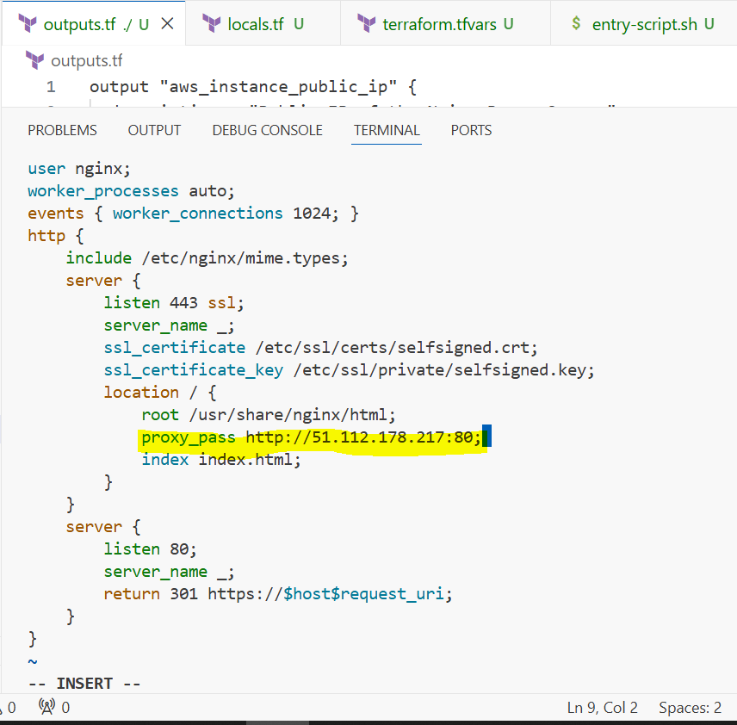

1. Restart Nginx:

sudo systemctl restart nginx



1. View Nginx logs and configuration files:

cat /var/log/nginx/error.log

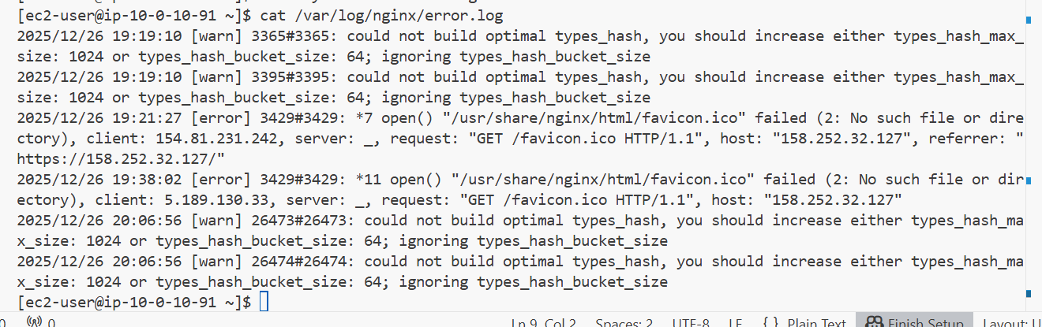

cat /var/log/nginx/access.log

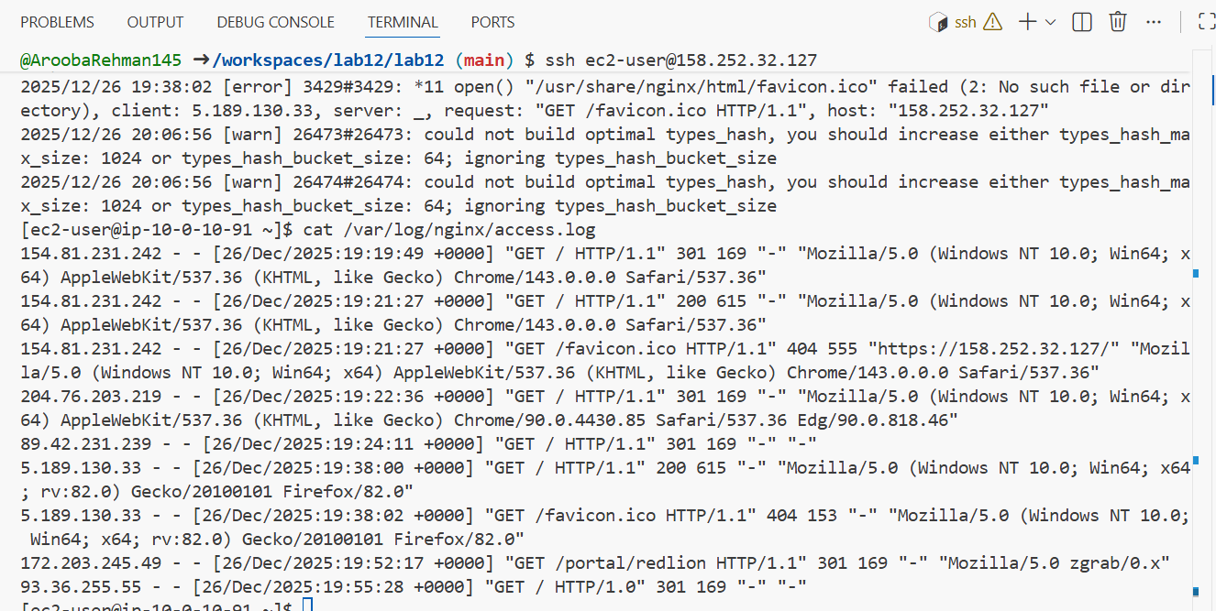

cat /etc/nginx/mime.types

* 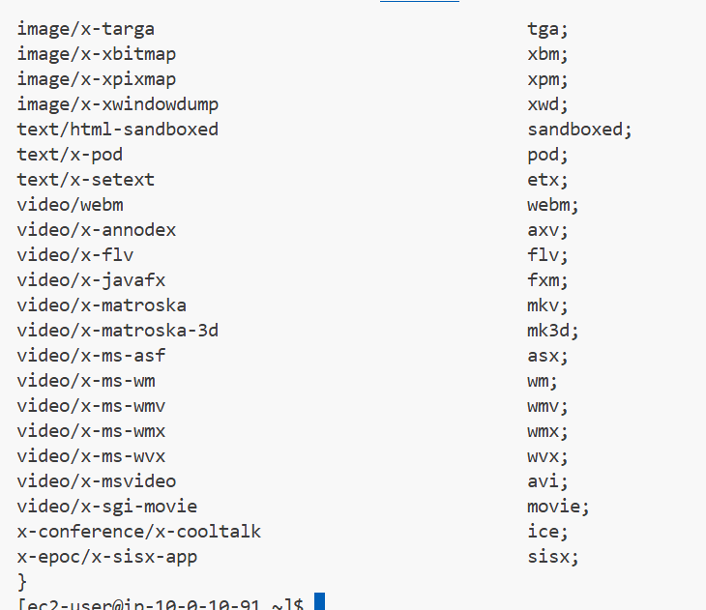

cat /etc/ssl/certs/selfsigned. crt

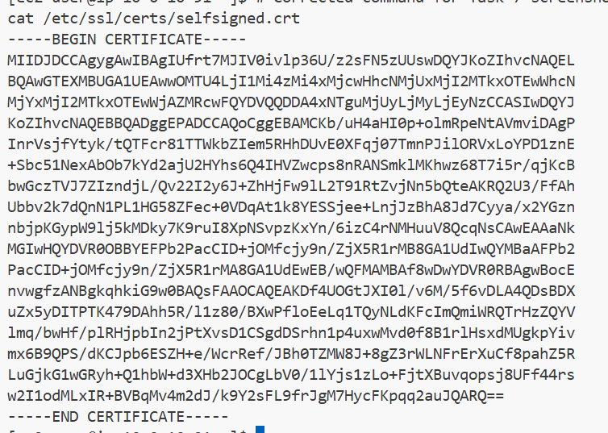

cat /etc/ssl/private/selfsigned.key

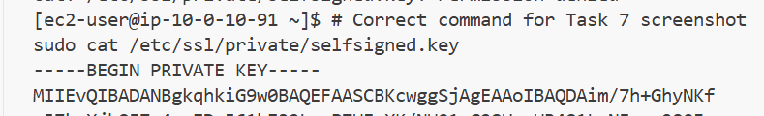

1. Test reverse proxy in browser:

* Open browser and navigate to https://<webserver-public-ip>
* You should see the web-1 Apache page through the Nginx proxy

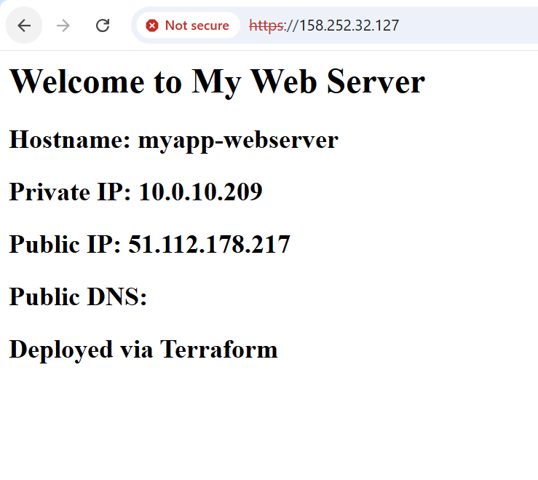

## **Task 8**

## **Configure Nginx as load balancer**

In this task, you will add a second backend server and configure Nginx to load balance between them.

1. Add the second web server module to main.tf:

module "myapp-web-2" {

source = "./modules/webserver"

env_prefix = var.env_prefix

instance_type = var.instance_type

availability_zone = var. availability_zone

public_key = var.public_key

my_ip = local.my_ip

vpc_id = aws_vpc.myapp_vpc. id

subnet_id = module.myapp-subnet.subnet. id

script_path = "./apache.sh"

instance_suffix = "2"

}

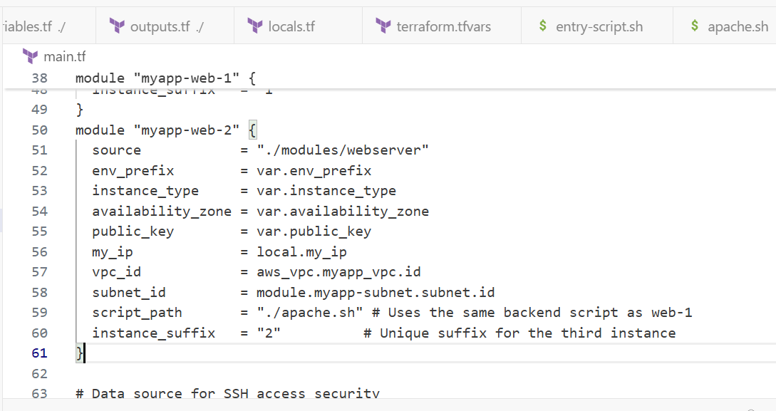

1. Update outputs.tf:

output "aws_web-2_public_ip" {

value = module. myapp-web-2.aws_instance.public_ip

}

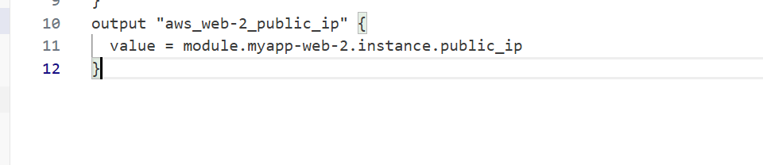

output "aws_web-2_public_ip" {

value = module.myapp-web-2.instance.public_ip

}

1. Apply the configuration:

terraform apply -auto-approve

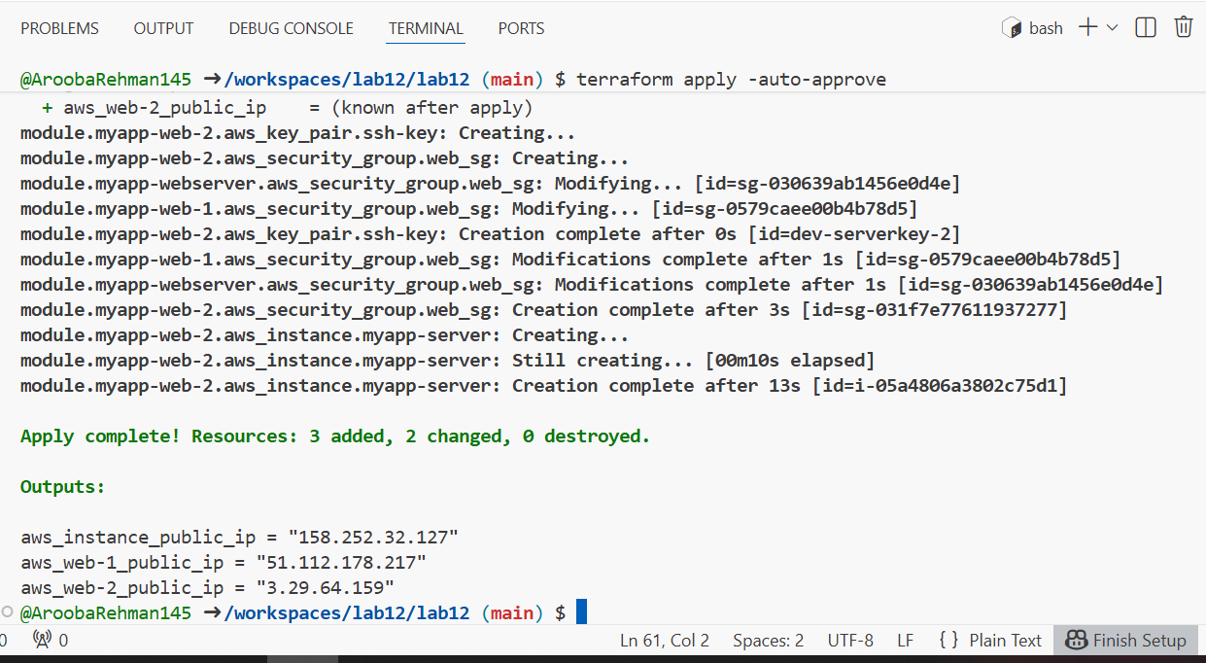

1. Get all outputs:

terraform output

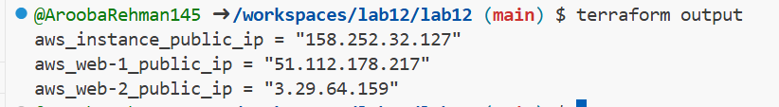

1. SSH into the webserver (Nginx proxy):

ssh ec2-user@<webserver-public-ip>

1. Edit Nginx configuration for load balancing:

sudo vim /etc/nginx/nginx.conf

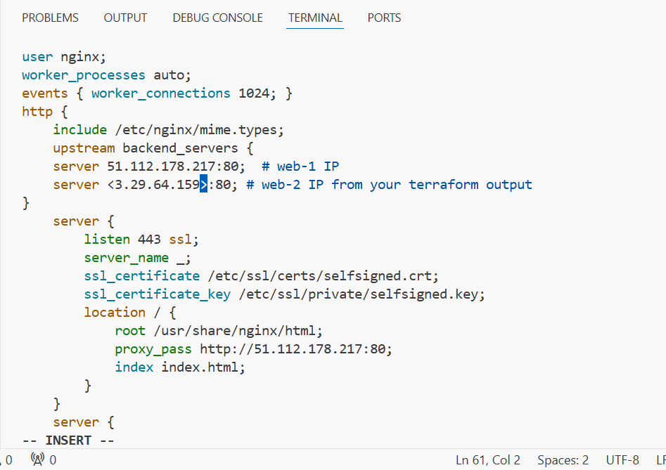

upstream backend_servers {

server 51.112.178.217:80; # web-1 IP

server <3.29.64.159>:80; # web-2 IP from your terraform output

}

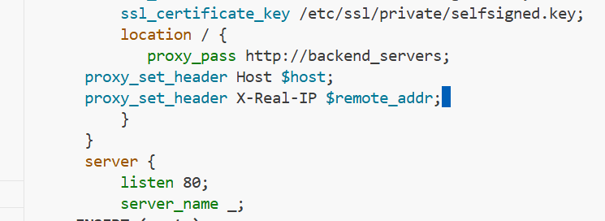

location / {

proxy_pass http://backend_servers;

proxy_set_header Host $host;

proxy_set_header X-Real-IP $remote_addr;

}

Update the upstream block and location:

upstream backend_servers {

server <web-1-public-ip>:80;

server <web-2-public-ip>: 80;

}

# ... in server block:

location / {

# root /usr/share/nginx/html;

# index index.html;

# proxy_pass http://<web-1-public-ip>:80;

proxy_pass http://backend_servers;

}

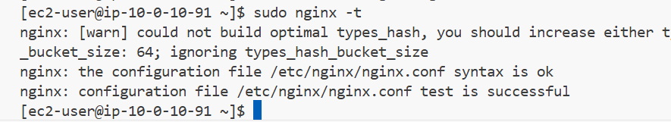

Sudo nginx -t

1. Restart Nginx:

sudo systemctl restart nginx

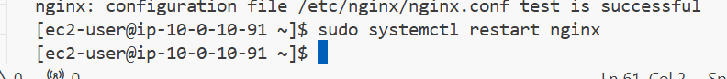

Sudo systemctl restart nginx

1. Test load balancing in browser:

* Open browser and navigate to https://<webserver-public-ip>
* Reload the page multiple times
* You should see the content alternating between web-1 and web-2 (check the hostname/IP in the page)

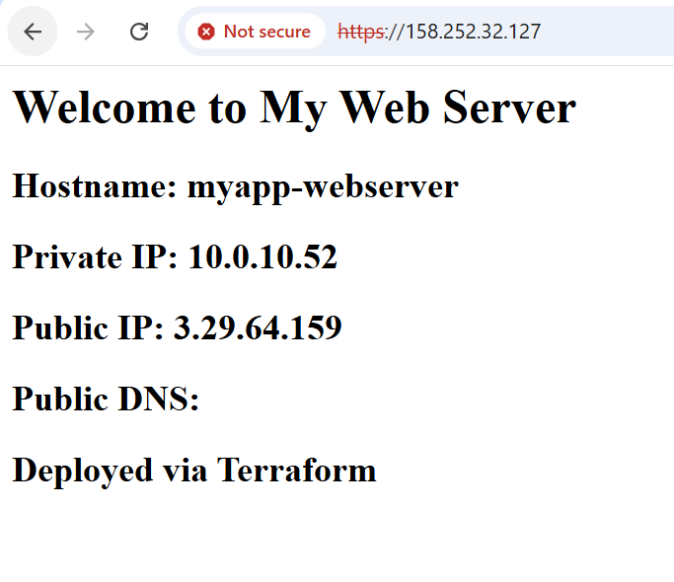

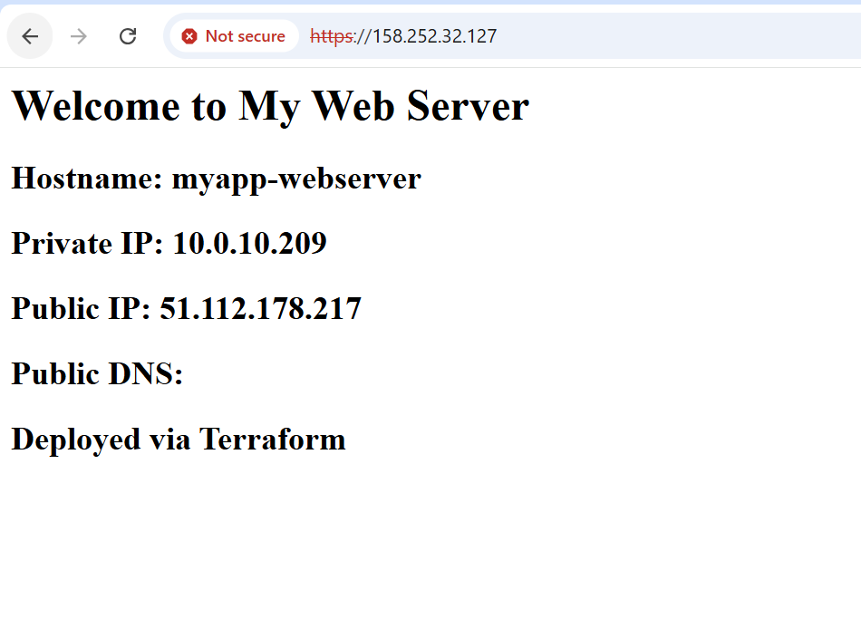

## **Task 9** Configure high availability with backup servers

In this task, you will configure one server as primary and another as backup for high availability.

1. SSH into the webserver:

ssh ec2-user@<webserver-public-ip>

ssh [ec2-user@158.252.32.127](mailto:ec2-user@158.252.32.127)

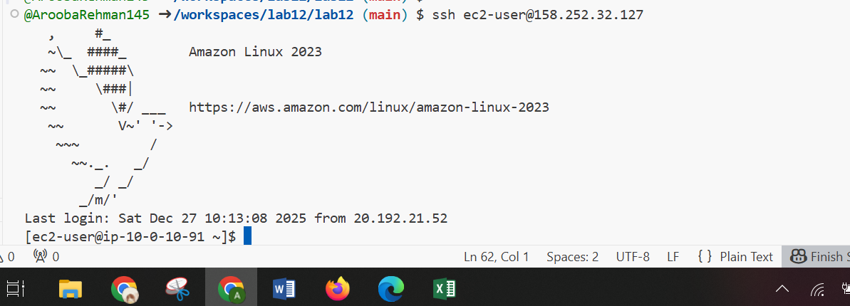

1. Edit Nginx configuration for high availability:

sudo vim /etc/nginx/nginx.conf

Update the upstream block to make web-2 a backup:

upstream backend_servers {

server <web-1-public-ip>:80;

server <web-2-public-ip>:80 backup;

}

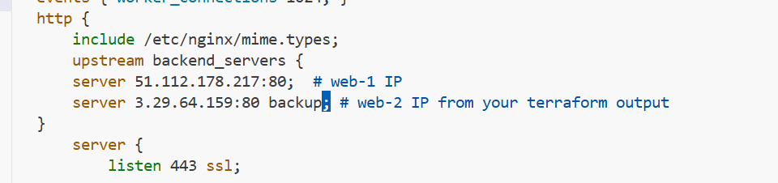

1. Restart Nginx:

sudo systemctl restart nginx

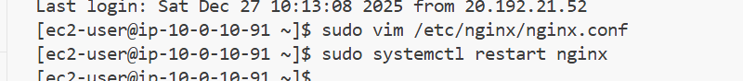

1. Test in browser:

* Open browser and navigate to https://<webserver-public-ip>
* Reload multiple times
* You should ONLY see web-1 (primary server)

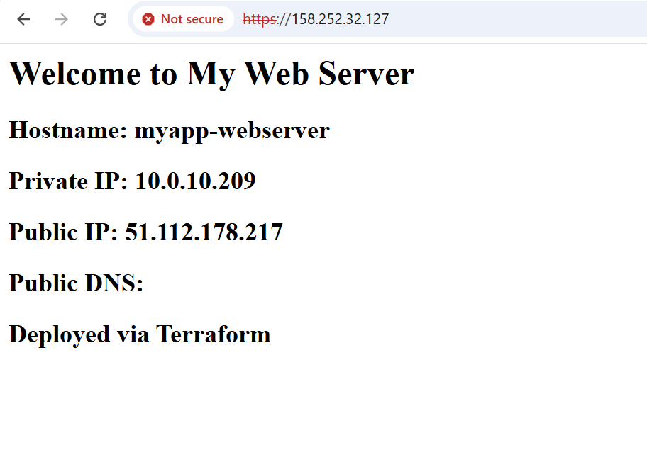

1. Switch backup configuration:

sudo vim /etc/nginx/nginx.conf

Update to make web-1 backup:

upstream backend_servers {

server <web-1-public-ip>: 80 backup;

server <web-2-public-ip>:80;

}

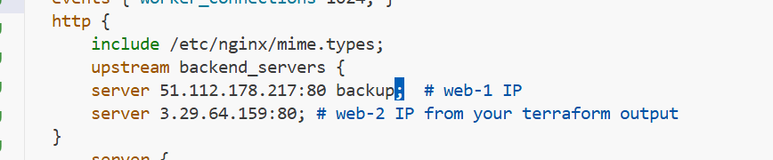

1. Restart Nginx:

sudo systemctl restart nginx

1. Test in browser:

* Reload multiple times
* You should ONLY see web-2 (now the primary server)

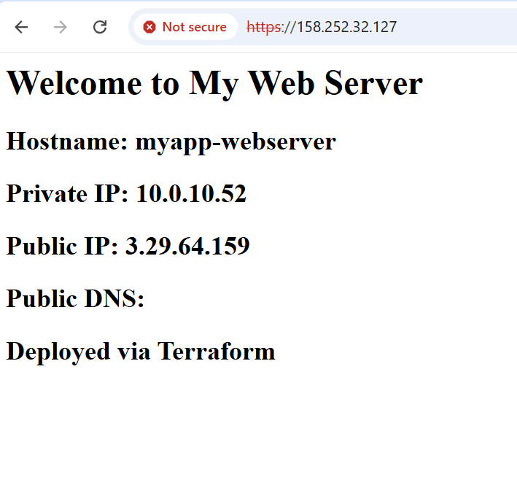

## **Task 10**

## Enable Nginx caching

In this task, you will enable caching in Nginx to improve performance.

1. SSH into the webserver:

ssh ec2-user@<webserver-public-ip>



1. Edit Nginx configuration to enable caching:

sudo vim /etc/nginx/nginx.conf

Add proxy cache configuration in the http block and location block:

http {

proxy_cache_path /var/cache/nginx levels=1:2 keys_zone=my_cache:10m inactive=60m max_size=1g;

log_format main '$remote_addr - $remote_user [$time_local] "$request" '

'$status $body_bytes_sent "$http_referer" '

'"$http_user_agent" "$http_x_forwarded_for"';

# ... other settings ...

upstream backend_servers {

server <web-1-public-ip>:80;

server <web-2-public-ip>: 80;

}

server {

listen 443 ssl;

server_name $PUBLIC_IP;

ssl_certificate /etc/ssl/certs/selfsigned.crt;

ssl_certificate_key /etc/ssl/private/selfsigned.key;

location / {

# root /usr/share/nginx/html;

# index index.html;

# proxy_pass http://<web-1-public-ip>: 80;

proxy_pass http://backend_servers;

proxy_cache my_cache;

proxy_cache_valid 200 60m;

proxy_cache_key "$scheme$request_uri";

add_header X-Cache-Status $upstream_cache_status;

}

}

# ... rest of config ...

}

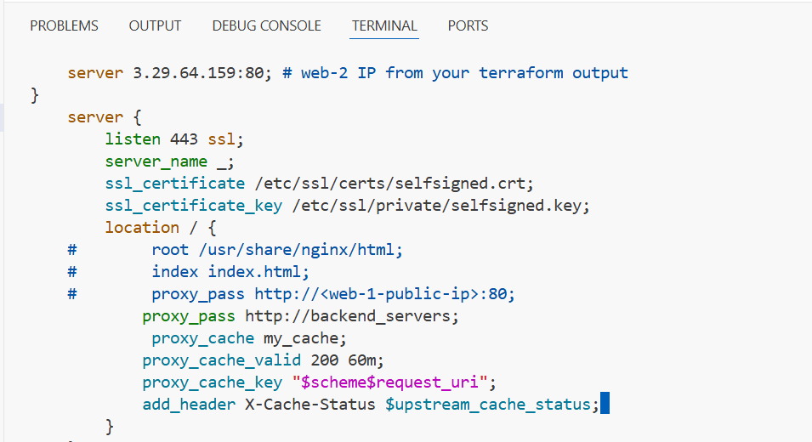

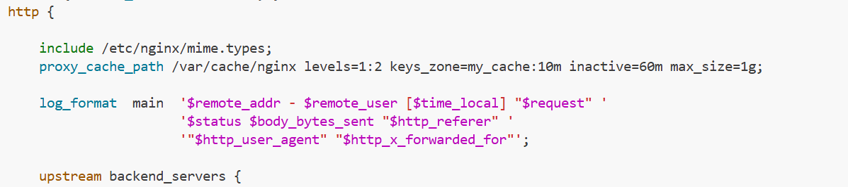

1. Restart Nginx:

sudo systemctl restart nginx

1. Test caching in browser:

* Open browser developer tools (F12)
* Navigate to Network tab
* Visit https://<webserver-public-ip>
* Check response headers for X-Cache-Status
* First request should show MISS
* Reload the page
* Second request should show HIT

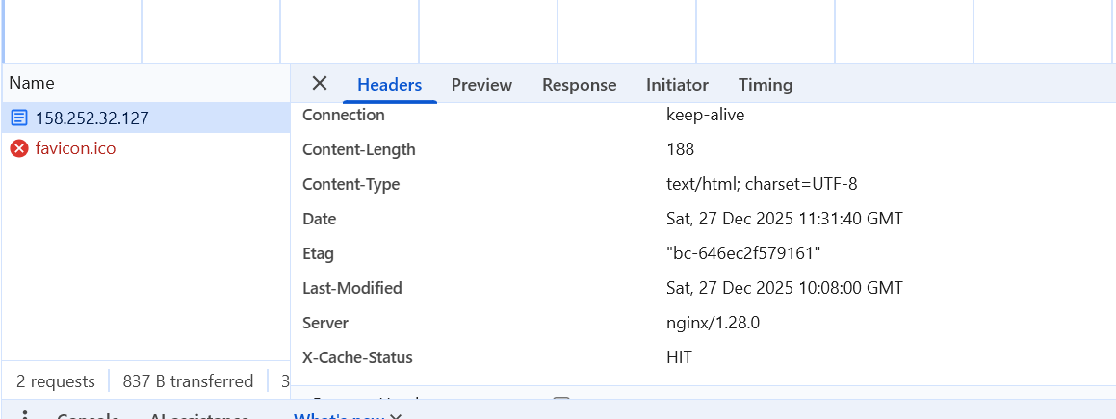

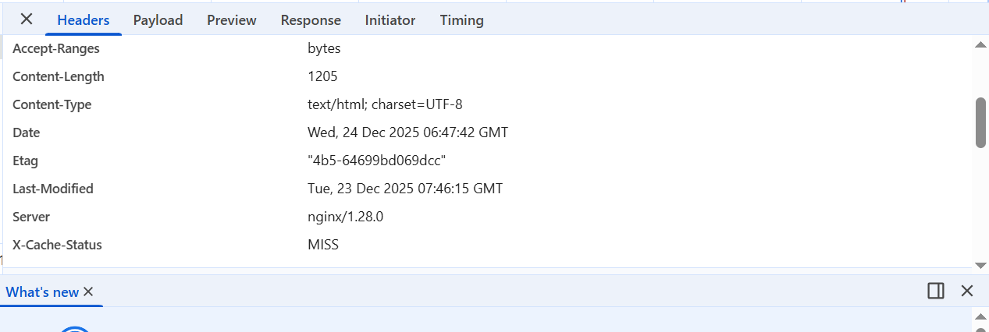

1. Verify cache directory:

ls -la /var/cache/nginx/

